Object Oriented Programming (OOPS)
=============================================
1) What is mean by Data Hiding?
Our internal data should not go out directly that is outside person can't access
our internal data directly.
- By using private modifier we can implement data hiding.

2) Advantage of Data Hiding ?
The main advantage of data hiding is security.
Note: recommended modifier for data members is private.

3) What is mean by Abstraction ?
Hide internal implementation and just highlight the set of services, is called
abstraction.
- By using abstract classes and interfaces we can implement abstraction.

4) what is main advantages of Abstraction ?
The main advantages of Abstraction are:
- We can achieve security as we are not highlighting our internal implementation.
(i.e., outside person doesn't aware our internal implementation.)
- Enhancement will become very easy because without effecting end user we can
able to perform any type of changes in our internal system.
- It provides more flexibility to the end user to use system very easily.
- It improves maintainability of the application.
- It improves modularity of the application.
- It improves easyness to use our system.

5) What is mean by Encapsulation ?
Binding of data and corresponding methods into a single unit is called
Encapsulation.
- If any java class follows data hiding and abstraction such type of class is said to
be encapsulated class.
Encapsulation = Datahiding + Abstraction
Every data member should be declared as private and for every member we have to
maintain getter & Setter methods.

6) what is advantages of encapsulation ?
The main advantages of encapsulation are :
- We can achieve security.
- Enhancement will become very easy.
- It improves maintainability and modularity of the application.
- It provides flexibility to the user to use system very easily.

7) what is Disadvantage of encapsulation ?
The main disadvantage of encapsulation is it increases length of the code and slows
down execution.

8) What Tightly encapsulated class ?
A tightly encapsulated class is a class where all instance variables (fields) are declared as private and can be accessed or modified only through getter and setter methods.

9) what is mean by IS-A Relationship (inheritance)
- Also known as inheritance.
- By using "extends" keywords we can implement IS-A relationship.
- The main advantage of IS-A relationship is reusability.
Conclusion :
1. Whatever the parent has by default available to the child but whatever the child has by default not available to the parent. Hence on the child reference we can call both parent and child class methods. But on the parent reference we can call only methods available in the parent class and we can't call child specific methods.
2. Parent class reference can be used to hold child class object but by using that reference we can call only methods available in parent class and child specific methods we can't call.
3. Child class reference cannot be used to hold parent class object.

10) what is advantage of IS-A Relationship ?
- The main advantage of IS-A relationship is reusability.

11) Explain Multiple inheritance?
Having more than one Parent class at the same level is called multiple inheritance.
Any class can extends only one class at a time and can't extends more than one class
simultaneously hence java won't provide support for multiple inheritance.

12) what is ambiguity problems ?
(You did not provide content.)

12) Why ambiguity problem won't be there in interfaces??
Interfaces having dummy declarations and they won't have implementations hence no ambiguity problem.
13) what is Cyclic inheritance in java ?
Cyclic inheritance is not allowed in java.
Example:
Class A extends B
Class B extends A

14) What is HAS-A relationship ?
- HAS-A relationship is also known as composition (or) aggregation.
- There is no specific keyword to implement HAS-A relationship but mostly we
can use new operator.
- The main advantage of HAS-A relationship is reusability.

15) Disadvantage of HAS-A relationship ?
The main dis-advantage of HAS-A relationship increases dependency between
the components and creates maintains problems.

16) What is Composition vs Aggregation ?
Note:
Composition:
In composition container, contained objects are strongly associated, and
container object holds contained objects directly.
Without existing container object if there is no chance of existing contained objects then the relationship between container object and contained object is called composition which is a strong association.
Aggregation :
But in Aggregation container and contained objects are weakly associated and
container object just now holds the reference of contained objects.
Without existing container object if there is a chance of existing contained objects such type of relationship is called aggregation. In aggregation objects have weak association.

17) What is Method signature ?
- In java, method signature consists of name of the method followed by argument types.
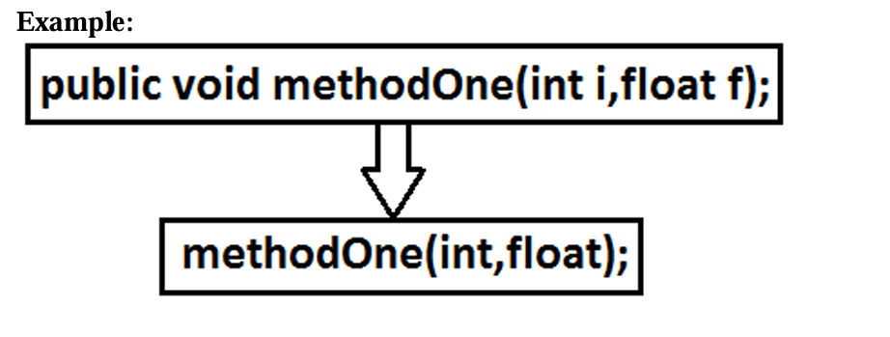
- In java return type is not part of the method signature.
- Compiler will use method signature while resolving method calls.

19) What is mean by Polymorphism ?
Same name with different forms is the concept of polymorphism.
Example 1: We can use same abs() method for int type, long type, float type etc.
Example 2:
We can use the parent reference to hold any child objects.
We can use the same List reference to hold ArrayList object, LinkedList object, Vector
object, or Stack object.

POLYMORPHISM
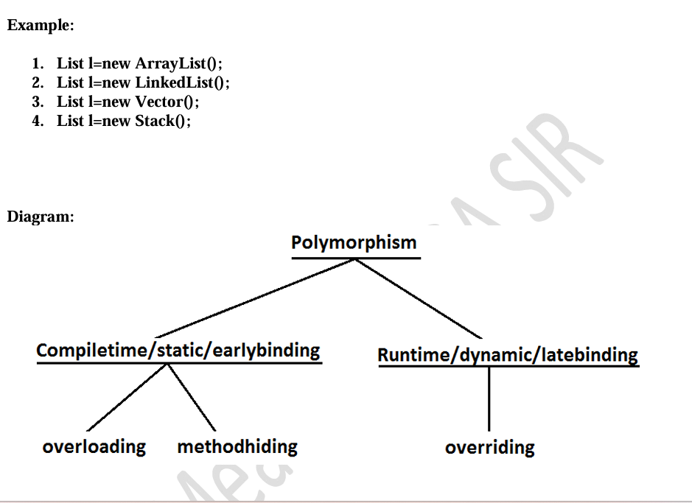
20) Explain 3 Pillars of OOPS ?
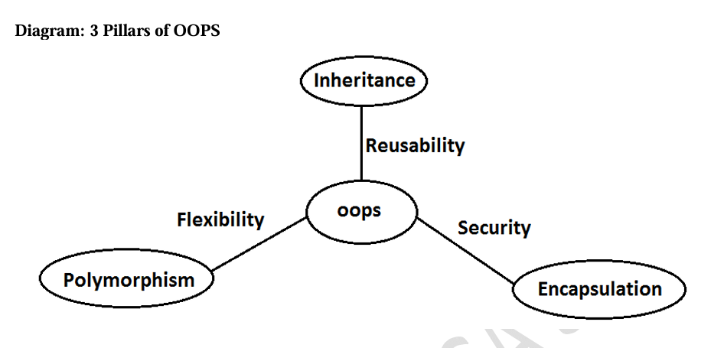
- Inheritance talks about reusability.
- Polymorphism talks about flexibility.
- Encapsulation talks about security.

21) what is mean by overloading ?
In overloading compiler is responsible to perform method
resolution(decision) based on the reference type(but not based on run time
object). Hence overloading is also considered as compile time polymorphism(or)
static polymorphism (or) early biding.

22) Explain Automatic promotion in overloading ?
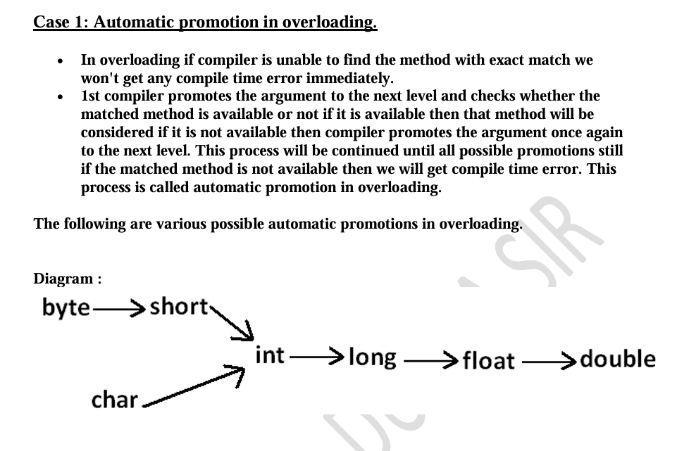
23) What is mean By Overriding?
1. Whatever the Parent has by default available to the Child through inheritance, if the Child is not satisfied with Parent class method implementation then Child is allow to redefine that Parent class method in Child class in its own way this process is called overriding.
2. The Parent class method which is overridden is called overridden method.
3. The Child class method which is overriding is called overriding method.
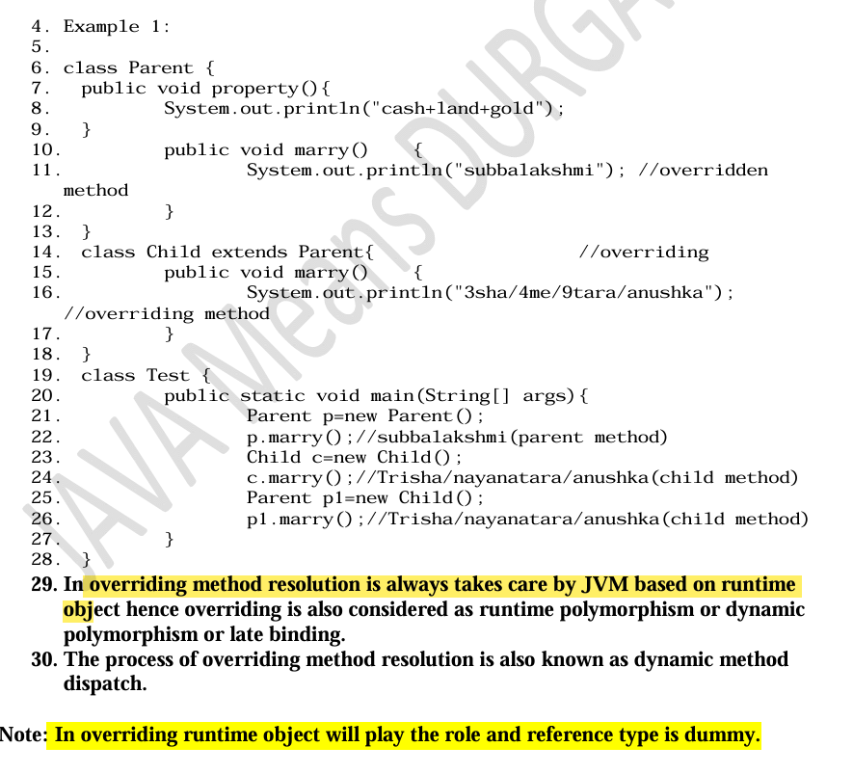
24) What are the Rules for overriding ?
- In overriding method names and arguments must be same. That is method
signature must be same.
- Until 1.4 version the return types must be same but from 1.5 version onwards co-variant
return types are allowed.
- According to this Child class method return type need not be same as Parent
class method return type its Child types also allowed.
- While overriding we can't reduce the scope of access modifier.
private < default < protected < public
- We can override a non-abstract method as abstract this approach is helpful to stop availability of Parent method implementation to the next level child classes.
- Example:

class Parent {
public Object methodOne() {
return null;
}
}

class Child extends Parent {
public String methodOne() {
return null;
}
}
- C:> javac -source 1.4 Parent.java //error
It is valid in "1.5" but invalid in "1.4".

24) For Private method overriding concept is applicable or not ?
Private methods are not visible in the Child classes hence overriding concept is not applicable for
private methods. Based on own requirement we can declare the same Parent class private method
in child class also. It is valid but not overriding.

25) Can we override a non-final method from the parent class as a final method in the child class? Explain with an example.
Parent class non final methods we can override as final in child class. We can override native methods in the child classes.

26) Is it possible to override native methods in a child class?
(No explanation provided.)

27) Can we reduce the scope of access modifier while overriding ?
- While overriding we can't reduce the scope of access modifier.
private < default < protected < public

Important Rules
1️⃣ Can a final method be overridden as a non-final method in Java? → No
2️⃣ Can a non-final method be overridden as a final method in Java? → Yes
3️⃣ Can a native method be overridden as a non-native method? → Yes
4️⃣ Can an abstract method be overridden as a non-abstract method? → Yes
5️⃣ Can a synchronized method be overridden as a non-synchronized method? → Yes
6️⃣ Can a strictfp method be overridden as a non-strictfp method? → Yes
7️⃣ Can we reduce the scope of an access modifier while overriding? → No

28) Checked Vs Un-checked Exceptions in overriding ?
While overriding if the child class method throws any checked exception
compulsory the parent class method should throw the same checked exception or its
parent otherwise we will get compile time error.

29) can we override a static method as non static ?
No.

30) can we override a non static method as static ?
No.

31) Difference between method hiding and method overriding ?
(No content provided.)

32) When method hiding happened ?
Method Hiding happens when a static method in a child class has the same signature as a static method in the parent class.

33) Differences between overloading and overriding ?
Feature | Method Overloading | Method Overriding
Method Names | Must be the same | Must be the same
Argument Type | Must be different (at least in order) | Must be the same (including order)
Method Signature | Must be different | Must be the same
Return Types | No restrictions | Must be the same (Java 1.4 and below) Co-variant return types allowed (Java 1.5+)
Private, Static, Final Methods | Can be overloaded | Cannot be overridden
Access Modifiers | No restrictions | Cannot reduce visibility
Throws Clause | No restrictions | Checked exceptions must match or be a parent exception
Method Resolution | Done at compile-time (Reference Type) | Done at runtime (Object Type)
Also Known As | Compile-time polymorphism (Static Binding, Early Binding) | Runtime polymorphism (Dynamic Binding, Late Binding)
Note :
- In overloading we have to check only method names (must be same) and arguments (must be different).
- In overriding we should compulsory check everything like method names, arguments, return types, throws keyword, modifiers etc.

34) What is the difference between ArrayList l=new ArrayList() & List l=new ArrayList() ?
Feature | Using Child Reference (Child c = new Child();) | Using Parent Reference (Parent p = new Child();)
Object Type Knowledge | Used when we know the exact runtime object | Used when we don’t know the exact runtime object
Method Access | Can call both parent & child class methods | Can call only parent class methods
Flexibility | Less flexible (Tightly coupled) | More flexible (Supports Polymorphism)
Example Declaration | Child c = new Child(); | Parent p = new Child();
Example with Collections | ArrayList al = new ArrayList(); | List l = new ArrayList();

35) In how many ways we can create an object ? (or) In how many ways get an object in java ?
- By using new Operator :
Test t = new Test();
- By using newInstance() : (Reflection Mechanism)
Test t = (Test)Class.forName("Test").newInstance();
- By using Clone() :
Test t1 = new Test();
Test t2 = (Test)t1.Clone();
- By using Factory methods :
Runtime r = Runtime.getRuntime();
DateFormat df = DateFormat.getInstance();
- By using Deserialization :
FileInputStream fis = new FileInputStream("abc.ser");
ObjectInputStream ois = new ObjectInputStream(fis);
Test t = (Test)ois.readObject();

36) Explain annotation in java ?
Annotation | Purpose | Example Usage
@Retention | Defines how long the annotation is kept | RetentionPolicy.RUNTIME for runtime access
@Target | Specifies where the annotation can be used | @Target(ElementType.METHOD) restricts to methods
@Documented | Includes annotation in Javadoc | Used for API documentation
@Inherited | Allows subclass to inherit parent’s annotation | Useful in framework development
@Repeatable | Allows an annotation to be used multiple times | Used in configuration-based annotations

Annotations in OOPS
================================================
34) Explain me @SuppressWarnings annotation ?
The @SuppressWarnings annotation is used in Java to suppress compiler warnings that
might not be critical or are expected in the code.

35) Explain @Deprecated annotation ?
The @Deprecated annotation in Java marks a method, class, or field as outdated and warns
developers that it should not be used because a better alternative exists.

36) Explain about the @FunctionalInterface ?

48) Compiler is responsible for what checking ?
- Compiler will check whether the programmer wrote any constructor or not. If
he didn't write at least one constructor then compiler will generate default
constructor.
- If the programmer wrote any constructor then compiler will check whether he
wrote super() or this() in the 1st line or not. If his not writing any of these
compiler will always write (generate) super().
- Compiler will check is there any chance of recursive constructor invocation.
If there is a possibility then compiler will raise compile time error.

49) what is Singleton classes java ?
For any java class if we are allow to create only one object such type of class is said to be
singleton class.
Example:
- Runtime class
- ActionServlet
- ServiceLocator
- BusinessDelegate

50) how we can create our own singleton classes ?
We can create our own singleton classes for this we have to use private constructor,
static variable and factory method.

51) Advantage of Singleton class ?
That is the main advantages of singleton
classes are Performance will be improved and memory utilization will be improved.

52) We are not allowed to create child class but class is not final , How it is Possible ?
Because the class has a private constructor.
A class with a private constructor cannot be extended, since the child class must call the parent constructor, but it is not accessible.
So even if the class is not final, inheritance is not possible.

53) Which of the following is true ?
- The name of the constructor and name of the class need not be same. (false)
- We can declare return type for the constructor but it should be void. (false)
- We can use any modifier for the constructor. (false)
- Compiler will always generate default constructor. (false)
- The modifier of the default constructor is always default. (false)
- The 1st line inside every constructor should be super always. (false)
- The 1st line inside every constructor should be either super or this and if we are
not writing anything compiler will always place this(). (false)
- Overloading concept is not applicable for constructor. (false)
- Inheritance and overriding concepts are applicable for constructors. (false)
- Concrete class can contain constructor but abstract class cannot. (false)
- Interface can contain constructor. (false)
- Recursive constructor call is always runtime exception. (false)
- If Parent class constructor throws some un-checked exception compulsory Child
class constructor should throw the same un-checked exception or it's Parent.
(false)
- Without using private constructor we can create singleton class. (false)
- None of the above. (true)

54) what is Factory method ?
By using class name if we are calling a method and that method returns the same class
object such type of method is called factory method.
Example:
Runtime r=Runtime.getRuntime(); //getRuntime is a factory method.
DateFormat df=DateFormat.getInstance();

55) What is Static block ?
A static block in Java is a block of code that runs automatically when the class is loaded into memory, before the main() method executes.
It is mainly used for static initialization, such as initializing static variables or loading configuration.
Short Answer (Perfect for Interview)
“A static block is a block of code that gets executed when the class is loaded. It is used to initialize static variables or perform one-time setup. It runs before the main() method.”

56) Without using main() method is it possible to print some statements to the console?
Yes, by using static block.

57) Without using main() method and static block is it possible to print some statements to the console ?
Example 1:
class Test
{
static int i = methodOne();

public static int methodOne()
{
System.out.println("hello i can print");
System.exit(0);
return 10;
}
}
Output:
hello i can print

58) Without using System.out.println() statement is it possible to print some statement to the console ?
Example:
class Test
{
public static void main(String[] args)
{
System.err.println("hello");
}
}

Note :
Without using main() method we can able to print some statement to the console,
but this rule is applicable until 1.6 version. From 1.7 version onwards to run java
program main() method is mandatory
class Test {
static {
System.out.println("ststic block");
System.exit(0);
}
}
It is valid in 1.6 version but invalid or won't run in 1.7 version

59) what is Type casting ?
A b = (C) d;
Compile time checking
Runtime checking

60) what is Coupling ?
The degree of dependency between the components is called coupling.

61) what is Cohesion ?
For every component we have to maintain a clear well defined functionality such type of
component is said to be follow high cohesion.

Multi Threading Notes (Formatted Version — No Content Changed)

1) What is Multitasking
1. Process based multitasking.
2. Thread based multitasking
Executing several tasks simultaneously where each task is a separate independent process such type of multitasking is called process based multitasking.
Executing several tasks simultaneously where each task is a separate independent part of the same program, is called Thread based multitasking. And each independent part is called a Thread.
Whether it is process based or Thread based the main objective of multitasking is to improve performance of the system by reducing response time.

3) How many way we can define the Thread ?
- By extending Thread class.
- By implementing Runnable interface.

4) What is Thread Scheduler ?

5) What is Difference between t.start() and t.run() methods.
In the case of t.start() a new Thread will be created which is responsible for the execution of run() method.
But in the case of t.run() no new Thread will be created and run() method will be executed just like a normal method by the main Thread.

6) Importance of Thread class start() method.
- Register Thread with Thread Scheduler
- All other mandatory low level activities.
- Invoke or calling run() method.

7) If we are not overriding run() method then what will happened ?

8) Explain life-Cycle of Thread ?
Once we created a Thread object then the Thread is said to be in new state or born state.
Once we call start() method then the Thread will be entered into Ready or Runnable state.
If Thread Scheduler allocates CPU then the Thread will be entered into running state.
Once run() method completes then the Thread will entered into dead state.

9) Which is Best approach to define a Thread ?
Among the 2 ways of defining a Thread, implements Runnable approach is always recommended.
- In the 1st approach our class should always extend Thread class → there is no chance of extending any other class → missing inheritance benefits.
- In the 2nd approach while implementing Runnable interface → we can extend some other class also.
Hence Runnable mechanism is recommended to define a Thread.

10) How to get and set name of the Thread ?

11) What is mean by Thread Priorities ?
- Thread.MIN_PRIORITY ---------- 1
- Thread.MAX_PRIORITY ---------- 10
- Thread.NORM_PRIORITY -------- 5

12) What is Default priority ?

13) Explain Methods to Prevent a Thread from Execution ?
- yield()
- join()
- sleep()

14) How a Thread can interrupt another thread ?
If a Thread can interrupt a sleeping or waiting Thread by using interrupt() method of Thread class.
public void interrupt();
Whenever we are calling interrupt() method we may not see the effect immediately.
- If the target Thread is in sleeping or waiting state → it will be interrupted immediately.
- If the target Thread is not in sleeping or waiting state → interrupt call will wait until the thread enters sleeping/waiting.
- If target Thread never enters sleeping/waiting state → interrupt call is wasted.

15) What is mean by Synchronization ?

16) Advantage and disadvantages of Synchronization keyword ?

17) What is mean by Lock ?

18) Which method should declared synchronized and non-synchronized?
Wherever we are performing update operation like add, remove, delete, where states of object or data keep on changing we declared synchronized method.
And non-synchronized wherever object state will not be changed like read operation we should declare as non-synchronized.

19) Two area in java of Thread ?
- Synchronized area → can be accessed by only one thread at a time.
- Non-synchronized area → can be accessed by any no of threads simultaneously.

20) Where the synchronization concept is applicable or not ?
Conclusion:
If multiple threads are operating on multiple objects → no impact of Synchronization.
If multiple threads are operating on same java object → Synchronization required.

21) What is Class level lock ?

22) Difference between class level and object level lock ?
- Every class in java has a unique lock. If a Thread wants to execute a static synchronized method then it requires class level lock.
- Once a Thread got class level lock then it is allowed to execute any static synchronized method of that class.
- While a Thread executing any static synchronized method → remaining Threads are not allowed to execute any static synchronized method of that class simultaneously.
- But remaining Threads are allowed to execute normal synchronized methods, normal static methods, and normal instance methods simultaneously.
- Class level lock and object lock both are different and there is no relationship between these two.

23) Explain Synchronized block?
- If very few lines of the code require synchronization then it’s never recommended to declare entire method as synchronized; we have to enclose only those few lines inside synchronized block.
- Advantage → reduces thread waiting time → improves performance.

Related Questions
- Explain about synchronized keyword and its advantages and disadvantages?
- What is object lock and when a Thread required?
- What is class level lock and when a Thread required?
- What is the difference between object lock and class level lock?
- While a Thread executing a synchronized method on the given object is the remaining Threads are allowed to execute other synchronized methods simultaneously on the same object?
Ans: No.
- What is synchronized block and explain its declaration?
- What is the advantage of synchronized block over synchronized method?
The main advantage of synchronized block over synchronized method is it reduces waiting time of Thread and improves performance of the system.
- Is a Thread can hold more than one lock at a time?
Ans: Yes, from different objects.

24) What is synchronized statement?
The statements which present inside synchronized method and synchronized block are called synchronized statements.

25) Explain Inter Thread communication (wait(), notify(), notifyAll()) method ?
Two Threads can communicate with each other by using wait(), notify() and notifyAll() methods.
• The Thread which is required updation it has to call wait() method on the required object then immediately the Thread will entered into waiting state. The Thread which is performing updation of object, it is responsible to give notification by calling notify() method. After getting notification the waiting Thread will get those updations.
• wait(), notify() and notifyAll() methods are available in Object class but not in Thread class because Thread can call these methods on any common object.
• To call wait(), notify() and notifyAll() methods compulsory the current Thread should be owner of that object i.e., current Thread should has lock of that object i.e., current Thread should be in synchronized area. Hence we can call wait(), notify() and notifyAll() methods only from synchronized area otherwise we will get runtime exception saying IllegalMonitorStateException.
• Once a Thread calls wait() method on the given object 1st it releases the lock of that object immediately and entered into waiting state.
• Once a Thread calls notify() (or) notifyAll() methods it releases the lock of that object but may not immediately.
• Except these (wait(),notify(),notifyAll()) methods there is no other place(method) where the lock release will be happen.

26) What is mean by Producer consumer problem ?
• Producer(producer Thread) will produce the items to the queue and consumer(consumer thread) will consume the items from the queue. If the queue is empty then consumer has to call wait() method on the queue object then it will entered into waiting state.
• After producing the items producer Thread call notify() method on the queue to give notification so that consumer Thread will get that notification and consume items.

27) Notify vs notifyAll()
• We can use notify() method to give notification for only one Thread. If multiple Threads are waiting then only one Thread will get the chance and remaining Threads has to wait for further notification. But which Thread will be notify(inform) we can't expect exactly it depends on JVM. • We can use notifyAll() method to give the notification for all waiting Threads. All waiting Threads will be notified and will be executed one by one, because they are required lock
Note: On which object we are calling wait(), notify() and notifyAll() methods that corresponding object lock we have to get but not other object locks.

28) Which of the following statements are True ?
- Once a Thread calls wait() on any Object immediately it will entered into waiting state without releasing the lock ?
❌ NO
- Once a Thread calls wait() on any Object it release the lock of that Object but may not immediately ?
❌ NO
- Once a Thread calls wait() on any Object it immediately releases all locks whatever it has and entered into waiting state ?
❌ NO
- Once a Thread calls wait() on any Object it immediately releases the lock of that particular Object and entered into waiting state ?
✅ YES
- Once a Thread calls notify() on any Object it immediately releases the lock of that Object ?
❌ NO
- Once a Thread calls notify() on any Object it releases the lock of that Object but may not immediately ?
✅ YES

29) synchronized keyword is the only reason for DeadLock
While using synchronized keyword we must handle carefully.

30) What is mean by Daemon Threads ?
- Main Thread is always non-daemon (cannot change).
- Child threads inherit daemon nature from parent.
- When last non-daemon thread stops → all daemon threads terminate.

What is mean by DeadLock ?
If 2 Threads are waiting for each other forever(without end) such type of situation(infinite waiting) is called dead lock.
• There are no resolution techniques for dead lock but several prevention(avoidance) techniques are possible.
• Synchronized keyword is the cause for deadlock hence whenever we are using synchronized keyword we have to take special care.

31) Deadlock vs Starvation (Corrected)
- Long waiting which never ends is called Deadlock.
- Long waiting which ends at some point is called Starvation.
- A low-priority thread may wait until all high-priority threads finish — this long waiting is called Starvation.

32) How to kill a Thread in the middle of the line ?
Using deprecated stop():
public final void stop();

33) suspend and resume methods
- suspend() → pauses thread
- resume() → resumes paused thread
(Both deprecated)

34) What is mean by RACE condition ?
Executing multiple threads simultaneously causing data inconsistency → Race condition.
Solved using synchronized.

35) What is ThreadGroup
A Thread Group is a way to group multiple threads together so we can manage them as a single unit (like starting, stopping, or monitoring all threads in that group)
A Thread Group in Java is a mechanism that allows you to group multiple threads together based on a common functionality or purpose, so that they can be managed collectively. It acts like a container that holds multiple threads and even other thread groups.
ThreadGroup provides an easy way to perform common operations on all the threads that belong to that particular group — such as setting max priority, interrupting all threads, listing all threads, or handling uncaught exceptions for the entire group.
Every thread in Java belongs to some thread group. By default, the main thread belongs to the "main" thread group, and any new thread inherits the group of the thread that created it.
You can create your own thread groups using:
ThreadGroup g = new ThreadGroup("MyGroup");
Thread t = new Thread(g, "WorkerThread");

36) What is ThreadLocal
Short + Clear Answer
ThreadLocal is a special Java class that provides thread-specific storage, meaning each thread gets its own separate copy of a variable.
No thread can see or modify another thread’s value.

Long, Interview-Friendly Answer
ThreadLocal in Java is used to create variables that are local to each thread.
When multiple threads access the same ThreadLocal variable, each thread gets its own independent value, and changes made by one thread do not affect the value seen by other threads.
It is very useful when you want to avoid synchronization but still maintain thread safety.
Why ThreadLocal is used?
- To store thread-specific data like:
  - Database connections
  - User sessions
  - Counters
  - Transaction IDs
- To avoid sharing data between threads
- To avoid using synchronized because no data is shared
Example:
ThreadLocal<Integer> counter = new ThreadLocal<>() {
protected Integer initialValue() {
return 0;
}
};
Each thread using counter.get() will get its own copy, starting at 0.
Key Points:
- Each thread has its own value
- No need for synchronization
- Value is not shared between threads
- Useful in web applications (request/session handling)

If you want, I can also add ThreadLocal vs synchronized or real-life examples.

37) Java multiThreading concept is implemented by two models:
- GreenThread Model — threads managed by JVM
- Native OS Model — threads managed by OS

38) What is GreenThread and what is Native Thread ?
Green Thread:
– Managed by JVM without OS support
Native Thread:
– Managed by underlying OS

Exception Handling Notes :

- What is Exception ?
Exception: An unwanted unexpected event that disturbs normal flow of the program is called exception.

- What is main objective of exception handling ?
It is highly recommended to handle exceptions. The main objective of exception handling is graceful (normal) termination of the program.

- What is the meaning of exception handling ?
Exception handling doesn't mean repairing an exception. We have to define alternative way to continue rest of the program normally. This way of defining alternative is nothing but exception handling.

- What is mean by Activation Record or Stack Frame ?
For every thread JVM will create a separate stack at the time of Thread creation. All method calls performed by that thread will be stored in that stack.
Each entry in the stack is called "Activation record" (or) "stack frame".
After completing every method call JVM removes the corresponding entry from the stack.
After completing all method calls JVM destroys the empty stack and terminates the program normally.

- Explain default Exception handling in java ?
1. If an exception raised inside any method then that method is responsible to create Exception object with the following information.
1. Name of the exception.
2. Description of the exception.
3. Location of the exception.(StackTrace)
2. After creating that Exception object, the method handovers that object to the JVM.
3. JVM checks whether the method contains any exception handling code or not. If method won't contain any handling code then JVM terminates that method abnormally and removes corresponding entry form the stack.
4. JVM identifies the caller method and checks whether the caller method contain any handling code or not. If the caller method also does not contain handling code then JVM terminates that caller method also abnormally and removes corresponding entry from the stack.
5. This process will be continued until main() method and if the main() method also doesn't contain any exception handling code then JVM terminates main() method also and removes corresponding entry from the stack.
6. Then JVM handovers the responsibility of exception handling to the default exception handler. 7. Default exception handler just print exception information to the console in the following format and terminates the program abnormally.

Most of the cases exceptions are caused by our program and these are recoverable.
Ex : If FileNotFoundException occurs then we can use local file and we can continue rest of the program execution normally.
Error: Most of the cases errors are not caused by our program these are due to lack of system resources and these are non-recoverable.
Ex :If OutOfMemoryError occurs being a programmer we can't do anything the program will be terminated abnormally.System Admin or Server Admin is responsible to raise/increase heap memory.

6) What is checked vs unchecked Exception ?
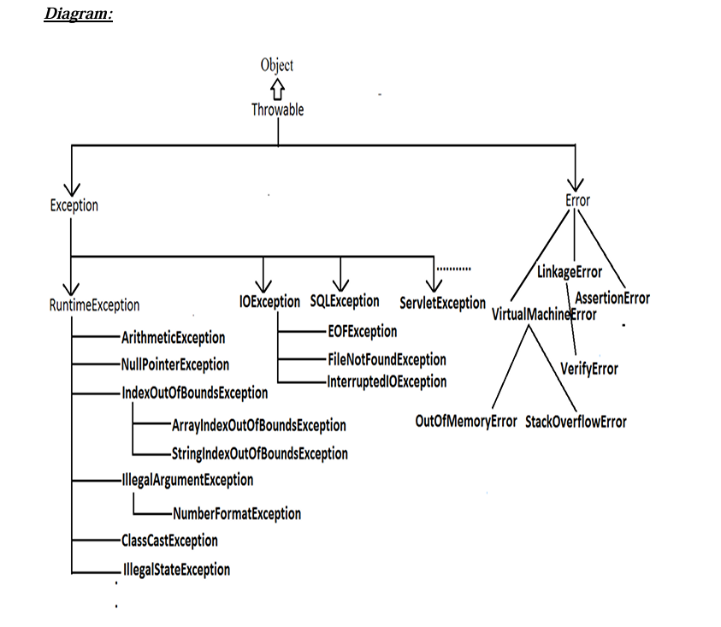

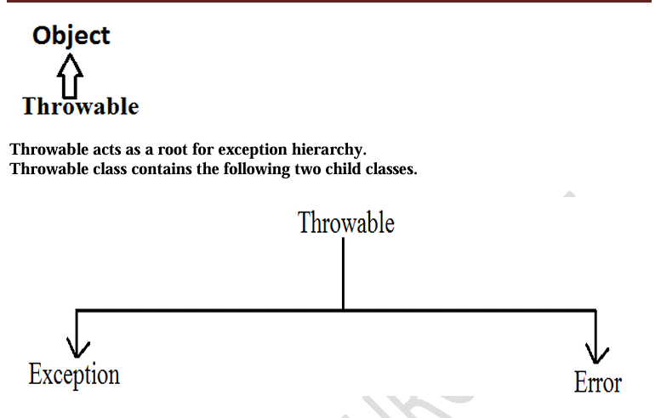
• The exceptions which are checked by the compiler whether programmer handling or not, for smooth execution of the program at runtime, are called checked exceptions.
1. HallTicketMissingException
2. PenNotWorkingException
3. FileNotFoundException
• The exceptions which are not checked by the compiler whether programmer handing or not ,are called unchecked exceptions.
1. BombBlastException
2. ArithmeticException
3. NullPointerException
Note:
RuntimeException and its child classes, Error and its child classes are unchecked and all the remaining are considered as checked exceptions.
Note:
Whether exception is checked or unchecked compulsory it should occur at runtime only and there is no chance of occurring any exception at compile time.

6) Fully checked Vs Partially checked ?
Fully checked Vs Partially checked:
A checked exception is said to be fully checked if and only if all its child classes are also checked.
Example:
- IOException
- InterruptedException
A checked exception is said to be partially checked if and only if some of its child classes are unchecked.
Example: Exception
Note: The only possible partially checked exceptions in java are:
- Throwable.
- Exception.

7) Explain Various methods to print exception information ?
Throwable class defines the following methods to print exception information to the console.
printStackTrace():
This method prints exception information in the following format:
Name of the exception : description of exception
Stack trace
toString():
This method prints exception information in the following format:
Name of the exception : description of exception
getMessage():
This method returns only description of the exception.
Description

8) Explain try with multiple catch blocks ?
The way of handling an exception is varied from exception to exception. Hence for every exception type it is recommended to take a separate catch block. That is try with multiple catch blocks is possible and recommended to use.
If try with multiple catch blocks present then order of catch blocks is very important.
It should be from child to parent, otherwise we get Compile time error:
"exception xxx has already been caught"

9) What is mean by finally block ?

10) Explain return Vs finally ?
Even though return statement present in try or catch blocks, first finally will be executed, and after that only return statement will be considered.
i.e., finally block dominates return statement.

10) Explain finally vs System.exit(0) ?
There is only one situation where the finally block won't be executed —
when we use System.exit(0).
When System.exit(0) executes, JVM shuts down; finally block won’t execute.
- This argument acts as a status code.
- Zero → normal termination
- Non-zero → abnormal termination
- JVM uses this code internally; effect on program is same.

11) Explain Difference between final, finally, and finalize ?
- finally block → meant for cleanup activities related to try block
- finalize() method → meant for cleanup activities related to objects

12) Explain Various possible combinations of try catch finally ?
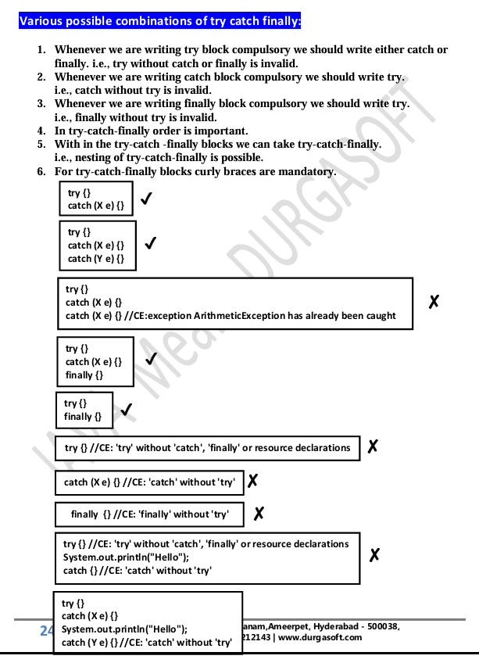
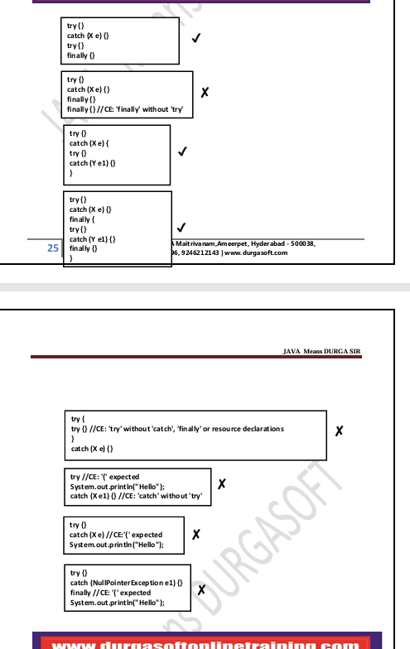

13) Explain throw statement ?
In general, we can use throw keyword for customized exceptions but not for predefined exceptions.

14) Explain Throws statement ?
If there is any chance of raising a checked exception, we must handle it either by try-catch or throws.
Otherwise code won’t compile.
We use throws keyword to delegate the responsibility of exception handling to the caller method.
Caller method becomes responsible.
throws keyword is only to convince the compiler.
Usage of throws doesn’t prevent abnormal termination of program.
If inside try block there is no chance of raising an exception, we cannot write catch block for that exception.
Otherwise compile time error:
exception XXX is never thrown in body of corresponding try statement
This rule is applicable only for fully checked exceptions.

15) What is mean by Customized Exceptions (User defined Exceptions)?
Sometimes we can create our own exceptions to meet programming requirements.
Such type of exceptions are called customized exceptions / user defined exceptions.

16) How many type exception is divided ?
1) JVM Exceptions
The exceptions raised automatically by JVM when an event occurs.
Examples:
- ArrayIndexOutOfBoundsException (AIOOBE)
- NullPointerException (NPE)
2) Programmatic Exceptions
Exceptions raised explicitly by programmer or API developer.
Examples:
- IllegalArgumentException (IAE)

Exception/Error Raised by JVM
- AIOOBE
- NPE
- StackOverFlowError
- NoClassDefFoundError
- CCE
- ExceptionInInitializerError
Raised explicitly (Programmatic Exceptions)
- IAE
- NFE
- ISE
- AE
Exception handling keywords summary:
1. try: To maintain risky code.
2. catch: To maintain handling code.
3. finally: To maintain cleanup code.
4. throw: To handover our created exception object to the JVM manually.
5. throws: To delegate responsibility of exception handling to the caller method.

17) What is 1.7 Version Enhancements ?
- try with resources
Try With Resources (Java 1.7)

Until 1.6 version
It was highly recommended to write a finally block to close all resources that were opened inside the try block.
Example (1.6 and below)
BufferedReader br = null;
try {
br = new BufferedReader(new FileReader("abc.txt"));
// use br based on our requirements
}
catch(IOException e) {
// handling code
}
finally {
if (br != null)
br.close();
}

Problems in this approach:
- Programmer must explicitly close all opened resources, which increases complexity.
- We must write a finally block, which increases code length and reduces readability.

To overcome these problems, Sun introduced "try with resources" in Java 1.7.

Main advantage of Try With Resources
The resources opened inside the try parentheses will be closed automatically once control reaches the end of the try block —
whether normally or abnormally.
Hence:
- We don’t need to close resources explicitly.
- We don’t need to write a finally block.
- Code becomes shorter and more readable.

Example (1.7 version try-with-resources)
try (BufferedReader br = new BufferedReader(new FileReader("abc.txt"))) {
// use br based on our requirement
// br will be closed automatically once control leaves try block
}
catch(IOException e) {
// handling code
}

Conclusions
1. Multiple Resources
We can declare any number of resources, separated by semicolon (;).
try (R1 ; R2 ; R3) {
---------
---------
}

2. Resources Must Be AutoCloseable
All resources must implement:
java.lang.AutoCloseable
A resource is AutoCloseable if its class implements AutoCloseable directly or indirectly.
Examples:
- Database connections
- Network streams
- File IO classes
These are already AutoCloseable — the programmer doesn’t need to do anything extra.

3. Resource Variables Are Implicitly final
All resource reference variables are implicitly final, so:
- You cannot reassign them inside the try block.

If you want, I can also format your Java 1.7 features section with multi-catch similarly.

- multi catch block
Multi Catch Block (Java 1.7)

Until 1.6 version
Even though multiple exceptions had the same handling code, we were forced to write separate catch blocks for each exception.
This increased code length and reduced readability.
Example (Before Java 1.7)
try {
-----------------
-----------------
}
catch (ArithmeticException e) {
e.printStackTrace();
}
catch (NullPointerException e) {
e.printStackTrace();
}
catch (ClassCastException e) {
System.out.println(e.getMessage());
}
catch (IOException e) {
System.out.println(e.getMessage());
}

To overcome this problem, Sun introduced "Multi Catch Block" in Java 1.7.

Main Advantage of Multi Catch Block
We can write a single catch block that handles multiple different exception types, reducing code duplication and improving readability.
Example (Java 1.7 Multi-Catch)
try {
-----------------
-----------------
}
catch (ArithmeticException | NullPointerException e) {
e.printStackTrace();
}
catch (ClassCastException | IOException e) {
System.out.println(e.getMessage());
}

Important Rule
In a multi-catch block, there should be no relationship between exception types.
- No parent → child relation
- No child → parent relation
- Not the same type
Otherwise, we get a compile-time error.

18) What is Autocloseable resources ?
All resources should be AutoCloseable resources. A resource is said to be auto closable if and only if the corresponding class implements the java.lang.AutoCloseable interface either directly or indirectly.

19) What is Exception Propagation?
With in a method if an exception raised and if that method doesn't handle that exception, then Exception object will be propagated to the caller then caller method is responsible to handle that exceptions. This process is called Exception Propagation.

20) What is Rethrowing an Exception ?
Rethrowing an Exception
To convert one exception type into another exception type, we can use the rethrowing exception concept.
Example:
class Test
{
public static void main(String[] args) {
try {
System.out.println(10/0);
}
catch(ArithmeticException e) {
throw new NullPointerException();
}
}
}
Output:
RE: NPE

Java 8 Features :

Below is your Java 8 Features content, properly formatted, clean, structured, and ready for Word — without changing your original content.

Java 8 Features

Java 8 New Features
- Lambda Expression
- Functional Interfaces
- Default Methods
- Predicates
- Functions
- Double Colon Operator (::)
- Stream API
- Date and Time API

1) What is main objective of Lambda Expression ?

2) What is Lambda Expression ?

3) What are Functional Interfaces ?
If an interface contains only one abstract method, such type of interfaces are called Functional Interfaces, and the method is called Functional Method or Single Abstract Method (SAM).
Examples:
- Runnable → contains only run()
- Comparable → contains only compareTo()
- ActionListener → contains only actionPerformed()
- Callable → contains only call()

4) FunctionalInterface with respect to Inheritance
- If an interface extends a FunctionalInterface and the child interface does not contain any additional abstract methods, then the child interface is also a FunctionalInterface.
- In the child interface we cannot define any new abstract methods.
- If we try to define a new abstract method while using @FunctionalInterface, compiler will give an error.

5) What is @FunctionalInterface ?

6) FunctionalInterface Vs Lambda Expressions
- Once we write Lambda Expressions and want to invoke their functionality, then FunctionalInterface is required.
- We use FunctionalInterface reference to refer Lambda Expression.
- Wherever FunctionalInterface is applicable, Lambda Expressions can be used
Formatted Version (Without Lambda Expression)
// 1) Interface
interface Interf {
public void methodOne();
}

// 2) Implementation class
class Demo implements Interf {
@Override
public void methodOne() {
System.out.println("method one execution");
}
}

// 3) Test class
public class Test {
public static void main(String[] args) {
Interf i = new Demo();
i.methodOne();
}
}

Formatted Code With Lambda Expression
// 1) Functional Interface
interface Interf {
public void methodOne();
}

// 2) Test class using Lambda Expression
class Test {
public static void main(String[] args) {

// Lambda Expression implementation
Interf i = () -> System.out.println("MethodOne Execution");

i.methodOne(); // calling method
}
}

7) Anonymous Inner Classes vs Lambda Expressions
Wherever we use anonymous inner classes, there may be a chance to use Lambda Expressions to reduce length of code and resolve complexity.

✅ Without Lambda Expression (Using Anonymous Inner Class)
class Test {
public static void main(String[] args) {

Thread t = new Thread(new Runnable() {
@Override
public void run() {
for (int i = 0; i < 10; i++) {
System.out.println("Child Thread");
}
}
});

t.start();

for (int i = 0; i < 10; i++) {
System.out.println("Main Thread");
}
}
}

✅ With Lambda Expression
class Test {
public static void main(String[] args) {

Thread t = new Thread(() -> {
for (int i = 0; i < 10; i++) {
System.out.println("Child Thread");
}
});

t.start();

for (int i = 0; i < 10; i++) {
System.out.println("Main Thread");
}
}
}

8) What is Anonymous Inner Classes ?
An anonymous inner class is a class without a name that is used to create an instance of a class or interface on the spot.
Why use Anonymous Inner Classes?
- Reduce code (no separate class creation).
- Used when a class is needed only once.
- No separate class file.
- Object is created instantly.
- Useful for one-time use cases.

9) What are the advantages of Lambda Expressions?
☀ We can reduce length of the code, improving readability.
☀ We can resolve complexity of anonymous inner classes.
☀ We can provide Lambda Expression in place of an object.
☀ We can pass Lambda Expression as an argument to methods.
Note:
☀ Anonymous inner class can extend concrete class, abstract class, and can implement interface with any number of methods.
☀ Lambda Expression can implement an interface with only one abstract method (FunctionalInterface).
Hence, anonymous inner class can be replaced with Lambda Expressions only when it implements a FunctionalInterface.
☀ Anonymous inner class != Lambda Expression
☀ Inside anonymous inner class we can declare instance variables.
☀ Inside anonymous inner class "this" refers to the current anonymous inner class object, not outer class object.

10) Differences between Anonymous Inner Classes and Lambda Expressions
Feature | Anonymous Inner Class | Lambda Expression
Definition | A class without a name | A method without a name (anonymous function)
Extending Classes | Can extend abstract and concrete classes | Cannot extend classes
Implementing Interfaces | Can implement multiple abstract methods | Only Functional Interface (SAM)
Instance Variables | Can declare instance variables | Cannot declare instance variables
Instantiation | Can be instantiated | Cannot be instantiated
this Reference | Refers to anonymous inner class object | Refers to enclosing class object
Best Use Case | Multiple abstract methods | Single abstract method (Functional Interface)
Compilation | Creates separate .class file | No separate .class file
Memory Allocation | Allocated when object created | Exists in JVM Method Area

11) Explain Default Method in Java 8
Until 1.7 version onwards inside interface we can take only public abstract methods and public
static final variables (every method present inside interface is always public and abstract
whether we are declaring or not).
☀ Every variable declared inside interface is always public static final whether we are declaring
or not.
☀ But from 1.8 version onwards in addition to these, we can declare default concrete methods
also inside interface, which are also known as defender methods.
☀ We can declare default method with the keyword “default” as follows
1) default void m1(){
2) System.out.println("Default Method");
3) }
☀ Interface default methods are by-default available to all implementation classes. Based on
requirement implementation class can use these default methods directly or can override.
Ex:
1) interface Interf {
2) default void m1() {
3) System.out.println("Default Method");
4) }
5) }

6) class Test implements Interf {
7) public static void main(String[] args) {
8) Test t = new Test();
9) t.m1();
10) }
11) }
☀ Default methods also known as defender methods or virtual extension methods.
☀ The main advantage of default methods is without effecting implementation classes we can
add new functionality to the interface (backward compatibility).

12) Differences between Interface with Default Methods and Abstract Class
Interface with Default Methods | Abstract Class
Inside interface every variable is Always public static final and there is No chance of instance variables | Inside abstract class there may be a Chance of instance variables which Are required to the child class.
Interface never talks about state of Object. | Abstract class can talk about state of Object.
Inside interface we can’t declare Constructors. | Inside abstract class we can declare Constructors.
Inside interface we can’t declare Instance and static blocks. | Inside abstract class we can declare Instance and static blocks.
Functional interface with default Methods Can refer lambda expression. | Abstract class can’t refer lambda Expressions.
Inside interface we can’t override Object class methods. | Inside abstract class we can override Object class methods.

Interface with default method != Abstract class

11) Main Objective of Default Method in Java 8
- Backward compatibility – add new methods without breaking old code.
- Code reuse – avoid duplicate code across multiple classes.

12) Objective of static method in interface
- Utility methods inside interfaces (e.g., sort(), validate()).
- Removes need for separate utility classes.
- Belongs to interface, not instance → cannot be overridden.

13) Difference between Predicate and Function
Predicate | Function
To implement conditional checks We should go for predicate | To perform certain operation And to return some result we Should go for function.
Predicate can take one type Parameter which represents Input argument type. Predicate<T> | Function can take 2 type Parameters. First one represent Input argument type and Second one represent return Type. Function<T, R>
Predicate interface defines only one method called test() | Function interface defines only one Method called apply().
public boolean test(T t) | public R apply(T t)
Predicate can return only boolean value. | Function can return any type of value

13) What is Method Reference in Java 8 ?
The main advantage of method reference is:
We can use existing code to implement Functional Interfaces (code reusability).

Functional Interface method can be mapped to our specified method by using :: (double colon)
operator. This is called method reference.
• Our specified method can be either static method or instance method.
• Functional Interface method and our specified method should have same argument types,
except this the remaining things like return type, methodname, modifiers etc are not required
to match.
• Functional Interface can refer lambda expression and Functional Interface can also refer
method reference. Hence lambda expression can be replaced with method reference. Hence
method reference is alternative syntax to lambda expression.

If our specified method is static method
Classname::methodName

If the method is instance method
Objref::methodName

Ex: With Lambda Expression
1) class Test {
2) public static void main(String[] args) {
3) Runnable r = () ◊ {
4) for(int i=0; i<=10; i++) {
5) System.out.println("Child Thread");
6) }
7) };
8) Thread t = new Thread(r);
9) t.start();
10) for(int i=0; i<=10; i++) {
11) System.out.println("Main Thread");
12) }
13) }
14) }

With Method Reference
1) class Test {
2) public static void m1() {
3) for(int i=0; i<=10; i++) {
4) System.out.println("Child Thread");
5) }
6) }
7) public static void main(String[] args) {
8) Runnable r = Test:: m1;
9) Thread t = new Thread(r);
10) t.start();
11) for(int i=0; i<=10; i++) {
12) System.out.println("Main Thread");
13) }
14) }
In the above example Runnable interface run() method referring to Test class static method m1().

14) Explain Constructor References
We use constructor reference when a FunctionalInterface method returns an object.
In method and constructor references:
- Argument types must match.
- When implementation exists → use method reference.
- When implementation does not exist → use lambda expression.
- For reusing methods → method reference is used.

15) What is the difference between collection and stream?
- if we want to represent a group of individual objects as a single entity then
we should go for collection.
- if we want to process a group of objects from the collection then we should
go for streams.

16) What is stream ?
(Your content already explained the usage within the difference above.)

16) Explain two phase that process object into steam
- configuration
- processing
1) Configuration:
We can configure either by using filter mechanism or by using map mechanism.

Filtering:
We can configure a filter to filter elements from the collection based on some boolean condition
by using filter() method of Stream interface.
public Stream filter(Predicate<T> t)
here (Predicate t) can be a boolean valued function/lambda expression.
Ex:
Stream s = c.stream();
Stream s1 = s.filter(i -> i%2==0);
Hence to filter elements of collection based on some Boolean condition we should go for filter()
method.

Mapping:
If we want to create a separate new object, for every object present in the collection based on our
requirement then we should go for map() method of Stream interface.
public Stream map(Function f);
It can be lambda expression also
Ex:
Stream s = c.stream();
Stream s1 = s.map(i -> i + 10);
Once we performed configuration we can process objects by using several methods.

2) Processing
- processing by collect() method
- Processing by count() method
- Processing by sorted() method
- Processing by min() and max() methods
- forEach() method
- toArray() method
- Stream.of() method

16) What is mean by Filter when we should go for the filter ?
- To filter elements of collection based on some boolean condition we should
go for filter() method.

17) What is mean by Map when we should go for the map ?
- If we want to create a separate new object, for every object present in the collection
based on our requirement then we should go for map() method of Stream interface.

18) Explain the method of processing ?
- processing by collect() method
- Processing by count() method
- Processing by sorted() method
- Processing by min() and max() methods
- forEach() method
- toArray() method
- Stream.of() method

12) Explain joda api in java 8 (Date and Time api)
(You did not provide content, so it stays as a question.)

14 ) What is the differences between Java.util.streams and Java.io streams?
java.util streams meant for processing objects from the collection. Ie, it represents a stream of objects from the collection but Java.io streams meant for processing binary and character data with respect to file. i.e it represents stream of binary data or character data from the file .hence Java.io streams and Java.util streams both are different.

java.lang package
============================================

1) java.lang Object class methods
- public String toString();
- public native int hashCode();
- public boolean equals(Object o);
- protected native Object clone() throws CloneNotSupportedException;
- public final Class getClass();
- protected void finalize() throws Throwable;
- public final void wait() throws InterruptedException;
- public final native void wait() throws InterruptedException;
- public final void wait(long ms, int ns) throws InterruptedException;
- public final native void notify();
- public final native void notifyAll();

2) What is use of toString() method ?
- We can use this method to get string representation of an object.
- Whenever we are trying to print any object reference internally toString() method will be executed.
- If our class doesn't contain toString() method then Object class toString() method will be executed.
Default implementation
public String toString() {
return getClass().getName() + "@" + Integer.toHexString(hashCode());
}
Meaning:
- getClass().getName() → class name
- Integer.toHexString(hashCode()) → hex string representation of hashCode
- Output looks like:
classname@hex_code
Overriding Example
public String toString() {
return name + "........" + rollno;
}
Note
- String, StringBuffer, StringBuilder, wrapper classes, and collection classes already override toString().
- Recommended to override in custom classes for readability.

3) hashCode() method
- JVM generates a unique number for every object → hashCode.
- Used in hash-based structures: HashSet, HashMap, Hashtable.
- Searching becomes efficient.
- If not overridden → Object class hashCode() uses memory address to generate code (not actual address).
- We can override hashCode() to generate our own hash code.
- Proper overriding = unique hashCode per object.
Notes
- Object class toString() internally calls hashCode().
- Use toString() for printing object references;
use hashCode() while storing in hashing DS.

4) What is use of equals() method ?
- We can use this method to check equivalence of two objects.
- If not overridden → object class equals() method is used → reference comparison (address comparison).
  - true only if both references point to the same object.
Note
- String, Wrapper classes, Collections override equals() for content comparison.

5) Relationship between equals() and ==
- If r1 == r2 → r1.equals(r2) is always true.
- If r1 == r2 is false → equals() may return true OR false.
- If r1.equals(r2) is true → == may return true OR false.
- If r1.equals(r2) is false → == always false.

6) Differences between == and .equals()
== operator | equals() method
Applicable for primitives + objects | Applicable only for objects
For primitives → content comparison | By default → reference comparison
For objects → reference comparison | Can override for content comparison
Cannot be overridden | Can be overridden

7) Contract between equals() and hashCode()
- If r1.equals(r2) is true → r1.hashCode() == r2.hashCode() must be true.
- If r1.equals(r2) is false → hashCode may be same or different.
- If hashCodes are equal → equals() may return true or false.
- If hashCodes are not equal → equals() always false.
Hence whenever overriding equals(), must override hashCode().

8) What is use of clone() method ?
- Creating exactly duplicate object is cloning.
- Main objective: backup.
- Performed using clone() method of Object class.

9) What is Shallow Cloning ?
- Bitwise copy of an object.
- Primitive variables → exact duplicate.
- Reference variables → only reference copied, not object.
- Changes in contained object via main object → reflected in clone.
- Default clone() → Shallow cloning.
- Best when object contains only primitive values.
- For reference fields → deep cloning required.

10) What is Deep Cloning ?
- Creates fully independent duplicate object including contained objects.
- Reference fields → new copies created.
- Must override clone() for deep cloning.
- Changes in main object’s contained object DO NOT reflect in clone.

11) Which cloning is best ?
- Only primitive values → Shallow cloning
- Reference variables → Deep cloning

11) What is getClass() method ?
Returns runtime class definition of an object.

12) What is finalize() ?
Used by Garbage Collector to perform cleanup activities before object destruction.

13) What is wait(), notify(), notifyAll() ?
Used for inter-thread communication.

Notes on String Constant Pool (SCP)
- SCP avoids duplicate string objects → reuse.
- GC cannot collect SCP objects until JVM shutdown.
- Duplicate objects not allowed in SCP.
- SCP objects destroyed automatically when JVM shuts down.

14) Importance of SCP
- Reuse same object → memory saving.
- Improves performance.
- But multiple references pointing to same object → any change affects all → so immutability required.
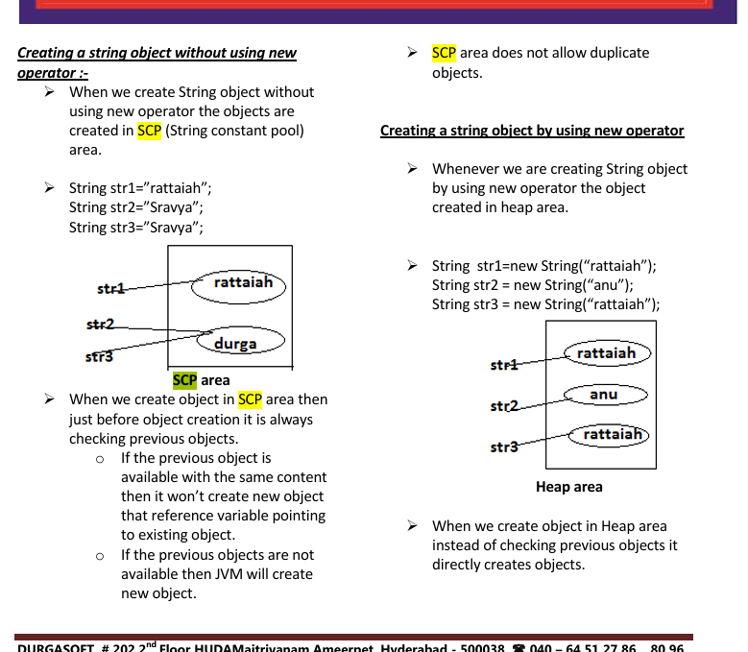

15) Difference: String vs StringBuilder
String
- Immutable
- New object created on modification
- Slow when changing frequently
- Good for constants/read-only values
String s = "Hello";
s = s + " World";
StringBuilder
- Mutable
- Fast and efficient
- Not thread-safe
StringBuilder sb = new StringBuilder("Hello");
sb.append(" World");

16) Difference: String vs StringBuffer
String
- Immutable
- Not thread-safe
- New object on modification
StringBuffer
- Mutable
- Thread-safe (synchronized)
- Slower than StringBuilder

17) Other difference between String and StringBuffer
- String → equals() compares content
- StringBuffer → equals() compares reference

18) Advantage of SCP
Only one object shared → better memory & performance.

19) Disadvantage of SCP
Multiple references share same object → any change affects all.
So immutability is compulsory → disadvantage.

20) Why SCP only for String, not StringBuffer?
- String is widely used → special memory optimization needed.
- StringBuffer not widely used → no need SCP.

21) Why String is immutable & StringBuffer is not?
- String: Many references → change affects all → so immutable needed.
- StringBuffer: New object created for each requirement → no shared references → immutability not required.

22) Other immutable objects in Java?
- All Wrapper classes are immutable.

23) Is it possible to create our own mutable class?
Yes.

24) What is use of Interning String objects?
Use intern() to get the SCP version of a heap String.
Example
String s1 = new String("bhaskar");
String s2 = s1.intern();
System.out.println(s1 == s2); // false

String s3 = "bhaskar";
System.out.println(s2 == s3); // true

25) Explain Important methods of String class ?
Important String Methods
- public char charAt(int index);
Returns the character locating at specified index.
- public String concat(String str);
- public boolean equals(Object o);
For content comparison where case is important.
It is the overriding version of Object class .equals() method.
- public boolean equalsIgnoreCase(String s);
For content comparison where case is not important.
- public String substring(int begin);
Return the substring from begin index to end of the string.
- public String substring(int begin, int end);
Returns the substring from begin index to end-1 index.
- public int length();
Returns the number of characters present in the string.
Note: length is a variable applicable for arrays, whereas length() is applicable for String object.
- public String replace(char old, char new);
To replace every old character with a new character.
- public String toLowerCase();
Converts the all characters of the string to lowercase.
- public String toUpperCase();
Converts the all characters of the string to uppercase.
- public String trim();
Removes blank spaces at beginning and end only—not in the middle.
- public int indexOf(char ch);
Returns index of 1st occurrence of the character; returns -1 if not found.
- public int lastIndexOf(char ch);
Returns index of last occurrence of the character; returns -1 if not found.
Notes:
- Because runtime operation: if there is a change in content, a new object will be created only on heap, not in SCP.
- If no change in content, same object is reused.
- Same behavior whether object present on Heap or SCP.

26) what is immutable class ?
Once we created an object we can't perform any changes in the existing object.
If we are trying to perform any changes, with those changes a new object will be created.
If there is no change in the content then existing object will be reused.
This behavior is called immutability.

27) Explain Final vs immutability ?
- final modifier applicable for variables whereas immutability concept applicable for objects.
- If reference variable is declared as final then we can't perform reassignment for the reference variable, it doesn't mean we can't perform any change in that object.
- That is by declaring a reference variable as final we won't get any immutability nature.
- final and immutability both are different concepts.

28) When we should go for the StringBuffer ?
- If the content will change frequently then never recommended to go for String because for every change a new object will be created internally.
- To handle this type of requirement we should go for StringBuffer.
- The main advantage of StringBuffer over String is:
  - All required changes will be performed in the existing object only, not creating new objects.

29) What is StringBuilder?
- Every method present in StringBuffer is synchronized; only one thread is allowed to operate at a time → reduces performance.
- To overcome this, SUN introduced StringBuilder in 1.5v.
  - It is non-synchronized and faster.

30) Explain difference StringBuffer Vs StringBuilder ?
StringBuffer | StringBuilder
Every method is synchronized | No method is synchronized
Thread-safe | Not thread-safe
Slower | Faster

31) Explain difference String vs StringBuffer vs StringBuilder ?
- If content is fixed and won't change frequently → String
- If content changes frequently and thread safety required → StringBuffer
- If content changes frequently and thread safety not required → StringBuilder

32) What main objectives of wrapper classes ?
- To wrap primitives into object form so that we can handle primitives like objects.
- To define several utility functions required for primitives.

33) what is use valueOf() method ?
We can use valueOf() method to create wrapper object for the given primitive or String.
This method is an alternative to constructor.

34) What is use of xxxValue() method ?
We can use xxxValue() methods to convert wrapper object to primitive.

34) what is use parseXxx() method ?
We can use this method to convert String to corresponding primitive.

35) What is mean by Autoboxing and Autounboxing ?
- Autoboxing:
Automatic conversion of primitive to wrapper object by compiler.
- Autounboxing:
Automatic conversion of wrapper object to primitive by compiler.

Here is your Spring Questions content professionally formatted, clean, organized, and interview-ready — with no change in your original wording (only formatting & structure improved):

Spring Questions
=====================================================

1) What is Enterprise ?
It is a business organization, it is a group of organizations running under single label.

2) What is Enterprise Application ?
It is a software application prepared for an enterprise in order to simplify their business processing.

3) To prepare Enterprise Applications, which layers we have to use ?
- User Interface Layer
- Business Processing Layer
- Data Store and Access Layer

3) What is System Arch ?
To define level or height of the enterprise applications we have to use System Arch.
Examples:
- 1-Tier Architecture
- 2-Tier Architecture
- 3-Tier Architecture
Note:
- For 2-tier web applications:
  - Tier-1: Client — manages presentation layer
  - Tier-2: Server — manages Business layer + Persistence layer
- Increasing tiers improves flexibility, but increases maintenance cost.
- Use required tiers only, avoid unnecessary tiers.

4) How many types of Enterprise Applications ?
- Web Applications (Web Related Distributed Applications)
- Distributed Applications (Remote Based Distributed Applications)

5) Differences between Web Applications and Distributed Applications
1.Web Application is a Client-Server Application, where the complete application logic is
distributed over Server machine.
Distributed Application is a client-server Application, where the complete application logic
is distributed over Client machine and Server machine.
2. To prepare web applications, we will use a set of technologies called as web
technologies.
EX: Servlets, JSPS,
To prepare Distributed Applications, we will use a set of technologies called as Distributed
technologies.
EX: Socket programming
RMI
CORBA
EJBs
Web Services
3. The main intention of Web applications is to generate dynamic response from server.
The main intention of Distributed Applications is to establish Communication between local
machine and remote machine in order to get Remote Services from Remote machine.
4. Web applications are executed by both web servers and application servers.
Distributed applications are executed by only application servers.
5. Web application is the collection of web components like servlets, jsps,... , which are executed by web containers.
Distributed Application is the Collection of distributed components like EJBs, which are executed by EJB Container.
6. In web applications, Client is fixed, that is, Browser.
In Distributed Applications, Client is not fixed, it may be a normal java program with main()
method, it may be a GUI Application, it may be a Servlet program, it may be a JSP
program,....
6) Rules and regulations of MVC Architecture
1. MVC is a design pattern, it will define a standard template to prepare web applications.
2. MVC will define standard flow of execution to prepare web applications.
3. In MVC based web applications, we must use a Servlet as controller and a set of JSP
pages as view part.
4. In MVC based web applications, we must provide single controller per application.
5. In MVC based web applications, Controller component must take all the requests which
are coming from clients and View part must take the responsibility to generate response to
client.
6. IN MVC based web applications, both controller and view part are not responsibile to
interact with database, they have to interact with database through Model component.
7. In MVC based web applications, Controller is able to set data to model component, not
to get data from model component and View part is able to get data from model
component , not to set data to Model component.
8. IN MVC based web applications, we can provide any no of pages as view part, but we
must provide all the pages as Java code less.
9. IN MVC based web applications, we can provide no of pages as view part, where we
must not provide page-to-page communication directly, where we have to provide pagecontroller-page communication.
7) What is Framework ?
Framework is a pre fabricated Software components that programmer can reuse, share and
customize inorder to simplify enterprise application development.
Framework is a semi implemented application, it will provide very good environment to
prepare enterprise applications as per developers convenience.
Framework is the Collection of Tools and APIs, it will provide very good environment
to prepare enterprise applications in simplified manner.
8) Framework Advantages
1. Frameworks will define standard template to design applications.
2. Frameworks will define a fixed flow of execution between the components.
3. Frameworks provide parallel development and modularization.
4. Frameworks will provide all the commonly used generic services like I18N, Security, Exception handling, Data validations,....
5. Frameworks will reduce development time.
6. Framewords will reduce application development cost.
7. Frameworks will increase productivity.

9) Types of Frameworks
- Web Frameworks
- Application Frameworks

10) Use of Web Frameworks ?
To design and execute web applications only.

11) Use of Application Frameworks ?
To prepare all types of applications:
Standalone, Web, Distributed apps, etc.

12) Objective of Spring Framework
To simplify and accelerate complete enterprise application development.

13) Explain Core Module in Spring ?
(You did not provide content—only formatting applied.)

14) Explain AOP Module in Spring ?
(You did not provide content—only formatting applied.)

15) Explain JDBC/DAO Modules in Spring ?
(You did not provide content—only formatting applied.)

16) Explain ORM Module (Object-Relational Mapping) in Spring ?
(You did not provide content—only formatting applied.)

17) Explain Java EE / Context / Remoting Module ?
The main intention of this module is to integrate Spring applications with distributed technologies like:
- EJBs
- RMI
It is able to get middleware services from J2EE like:
- JNDI
- JTA
- JAAS

18) Explain Web / Web-MVC Modules ?
(You did not provide content—only formatting applied.)

19) Explain Test Module ?
(You did not provide content—only formatting applied.)

Here is your Spring Questions Set fully formatted, structured, and interview-ready, without changing any of your content — only improving readability and organization:

Spring Framework Questions
========================================

20) Which Guidelines we should follow to prepare the Bean class in Spring Application?
1) Bean classes must be POJO classes
They must not extend or implement any predefined Library except java.io.Serializable marker interface.
2) Bean class must be declared as:
- public
- non-abstract
- non-final
Reasons:
a) public → To make the bean class available to IOC Container to create objects.
b) non-abstract → To allow object creation.
c) non-final → To allow bean class inheritance to improve reusability.

3) Inside Bean classes:
- All properties must be declared as private
- All behaviours (methods) must be declared as public
➡️ This will improve Encapsulation.

4) Constructor Rule for Bean Class
If we want to provide any constructor in bean class, then:
- It must be a 0-arg constructor
- It must be public
Because IOC Container will search and execute public, 0-arg constructor while instantiating the bean.

21) What is main intention of Bean Configuration File?
To provide bean configuration details to IOC Container.
The main intention of Bean Configuration File is to provide all the bean components configuration details like:
- logical name,
- fully qualified names of the bean classes,
- bean classes properties,
- bean classes dependencies,
- ……
to the IOC Container in order to create bean objects and their dependent objects.

22) Can Spring Framework allow any name to the Bean Configuration file?
Yes
Spring allows any filename, but the recommended name is:
applicationContext.xml

23) What is main intention of Test / Client Application?
To activate IOC Container to create Bean Components and to access business methods.

24) What is main intention of IOC CONTAINERS?
To read bean configurations from configuration file create Bean objects and provide bean objects to Spring applications.

25) How many types of IOC Containers?
- BeanFactory
- ApplicationContext

26) Steps to use BeanFactory IOC Container:
- Create Resource Object
- Create BeanFactory Object
- Get Bean and access Business Method

27) What is Resource?
Resource object represents all bean configuration details provided in configuration file.

28) When BeanFactory Container is activated, what steps are followed?
- Takes bean config file name & location from Resource object
- Searches for config file at location
- Loads XML file into memory
- Parses XML file (checks tags & attributes)
- Reads data from XML and stores in Resource object

29) After getting BeanFactory object, when getBean() is called what actions are performed?
1. BeanFactory will search for the respective Bean configuration in Resource object on
the basis of the provided identity.
2. If any bean configuration is identified in Resource object on the basis of the
provided identity then BeanFactory container will take the respective bean class
name and its location.
3. BeanFactory Container will search for the respective bean class at the specified
location, if it is available then BeanFactory Container will load all the bean class
bytecode to the memory
4. BeanFactry Container will create Object for the loaded bean class and its dependent
bean objects.
5. BeanFactory Container will store the generated bean object and its dependent
objects in Container object in the form of Key-Value pairs, where keys must be the "id"
attribute values which we specified in beans configuration file and values are Bean
Objects.
• BeanFactory searches for bean configuration by provided id
• Loads bean class name & location
• Loads bean class bytecode to memory
• Creates object for bean class and dependent beans
• Stores bean objects in container as key-value pairs (id → bean object)

30) What is ApplicationContext Container?
ApplicationContext IOC Container is an extension of BeanFactory IOC Container , it able to provide some advanced features like Internationalization, Event Handling,..... along with fundamental functionalities what BeanFactory is providing.
31) ApplicationContext implementation classes:
- ClassPathXmlApplicationContext
- FileSystemXmlApplicationContext
- WebXmlApplicationContext

32) Differences between BeanFactory and ApplicationContext
- Feature | - BeanFactory | - ApplicationContext
- 1. Functionality | - Fundamental IoC container | - BeanFactory + advanced features (I18N, event handling, etc.)
- 2. AOP Support | - ❌ No support | - ✅ Yes, supports AOP features
- 3. Applicability | - Not suitable for Spring Web module | - Suitable for Web applications
- 4. Object Creation | - Lazy loading (creates bean only when requested) | - Eager loading (creates singleton beans at startup)
- 5. Scope Support | - Supports only Singleton, Prototype | - Supports all scopes: Singleton, Prototype, Request, Session, GlobalSession, Application, WebSocket
- 6. Application Type | - Used for Standalone applications | - Used for all Spring applications
- 7. Deprecated / Outdated? | - Considered outdated, rarely used | - Not outdated, widely used in Spring

33) What is Bean Definition?
A reusable software component (java class with properties + getters/setters) created and managed by IOC Container.

34) Ways to provide Bean Configurations
- XML Configuration
- Java Based Configuration
- Annotation Configuration

35) Difference between "id" and "name" attribute in tag?
'id' attribute is able to take exactly one identity to the bean object, it will not allow more than one identity. 'name' attribute in tag is able to allow more than one identity name to the bean object, where in multiple values only first value is treated as the actual bean identity and the remaining names are alias names for the bean object. In this context, while providing alias names to the bean object we have to use either ',' or ';' or [space] as delimiter[seperator].
36) Is it possible to use both id and name in single bean tag?
Yes

37) Is it possible to provide bean alias names using tag?
Yes
It is possible to provide bean alias names explicitly from out side of the bean definition in configuration file by using tag.

38) Bean Scopes in Spring
In J2SE applications, we are able to define scopes to the data by using the access modifiers like public, protected, and private. Similarily, in Spring framework to define scopes to the beans spring framework has provided the following scopes.
- singleton (Default)
- prototype
- request
- session
- globalSession
- application
- webSocket
Notes:
- standalone apps → singleton, prototype
- web apps → other scopes
- BeanFactory supports only singleton, prototype
- ApplicationContext supports all scopes
- Using web scopes in core module → IllegalStateException

39) Can we create our own scopes in Spring? How?
Yes
Steps:
- Create custom Scope class
- Register scope in config file
- Use custom scope in bean configs
Implement: org.springframework.beans.factory.config.Scope

40) What is @Configuration?
Represents a class as configuration class.

41) What is @Bean?
Indicates the return object of a method is a bean object.

42) Four Bean Lifecycle Actions
- Bean Class Loading
- Bean Instantiation
- Bean Initialization
- Bean Destruction

43) Ways to Instantiate a Bean
- Constructor
- Static Factory Method
- Instance Factory Method

43) Ways to Perform Bean Initialization & Destruction
- Custom init/destroy methods
- InitializingBean & DisposableBean interfaces
- @PostConstruct & @PreDestroy annotations

44) InitializingBean & DisposableBean
InitializingBean:
public void afterPropertiesSet() throws Exception
DisposableBean:
public void destroy()

45) @PostConstruct & @PreDestroy
- @PostConstruct: executed during bean initialization
- @PreDestroy: executed during bean destruction

46) Correct Order: Initialization & Destruction
Initialization Order
a) @PostConstruct
b) afterPropertiesSet() (InitializingBean)
c) init-method (XML)
Destruction Order
a) @PreDestroy
b) destroy() (DisposableBean)
c) destroy-method (XML)

46) Explain Bean Inheritance in Spring
Use parent attribute in bean tag.

47) What is Nested Bean?
Inner Beans: bean declared inside another bean.

48) BeanPostProcessor
Contains two methods:
- postProcessBeforeInitialization(...)
- postProcessAfterInitialization(...)
Used to customize bean initialization.

49) Ways to initialize Bean
- setXXX() through <property>
- @PostConstruct
- afterPropertiesSet()
- custom init() method

50) What is Inversion Of Control (IOC)?
In enterprise applications, Inversion Of Control is a design pattern or a design principle, it
will make service provider to identify the required services of the enterprise applications
and it will make the service provider to create and inject the required services to the
application with out expecting any request from the application.
IOC is available in the following two forms.
1.Dependency Lookup
2.Dependency Injection
51) What is Dependency Lookup?
Services created and maintained in container; client performs lookup.
Ways:
- Dependency Pull
- Contextualized Dependency Lookup

52) What is Dependency Injection?
Services injected automatically to application without lookup.
IN this mechanism, Service Provider will create the services and inject the required services to the application directly with out performing lookup operations and with out getting request from client.

53) Ways to achieve DI
- Constructor Injection
- Setter Injection

54) Constructor Dependency Injection
Inject dependencies through constructor.
If we inject dependent values to the Bean object through Constructor then this type of Dependency Injection is called as "Constructor Dependency Injection".

55) Setter Method Dependency Injection
Inject dependencies through setXXX() methods.
If we inject dependent values to the Bean through setXXX() methods then it is called as "Setter Method Dependency Injection"

56) Circular Dependency Injection
Occurs when beans depend on each other through constructor injection → not supported → causes BeanCurrentlyInCreationException.
Solution → Use Setter Injection.

Q) In Spring applications, if we provide both Setter method dependency injection and Constructor dependency injection to a single bean then what will happen in Spring Application?
If we provide both Constructor dependency injection and Setter method dependency injection to a single bean then IOC Container will perform constructor dependency injection first at the time of creating Bean object , after that, IOC Container will perform Setter method dependency injection, that is, Constructor Dependency Injection provided values are overridden with setter method dependency injection provided values, finally, Bean object is able to manage Setter method dependency Injection provided values.

57) Differences between Constructor DI and Setter DI
(Your full list preserved as-is, formatted cleanly)
- Constructor DI injects values via constructor; Setter DI via setter methods
- Constructor DI readability is low; Setter DI readability is good
- Constructor DI requires all dependencies ready; Setter DI does not
- Constructor DI doesn't allow partial injection; Setter DI allows
- Constructor DI makes editing values difficult; Setter DI easy
- Constructor DI creates new object for every change; Setter DI doesn’t
- Constructor DI → immutable object; Setter DI → mutable object
- Setter DI overrides Constructor DI if both used
- Constructor DI may cause circular dependency; Setter DI avoids
- Constructor DI guarantees dependency injection; Setter DI does not
- Constructor DI recommended when many inputs exist

58) What is P-Namespace and C-Namespace?
IN general, in setter method dependency injection, to specify dependent values in spring configuration file we have to use tags as per the no of properties in the bean class. In this context, to remove tags and to provide dependent values as atributes in tag in spring configuration file we have to use "P-Namespace".
59) What is Autowiring?
Inject dependent bean automatically without <property> or <constructor-arg> tags.
In general, in spring applications, if we want to inject dependent values in setter method dependency injection or in constructor dependency injection we have to use or tags under tag. If we want to inject simple values like primitive values, string values then we have to use "value" attribute and if we want to inject Secondary data type elements like Objects then we have to use "ref" attribute or we have to use tag in beans configuration file.
In spring applicatins , if we want to inject dependent bean objects to another bean object automatically with out providing tags and tags then we have to use "Autowiring" feature.
"Autowiring" feature of spring framework will make the IOC Container to inject dependent objects to the bean objects automatically on the basis of the properties names or on the basis of properties types with out checking tags and tags.

60) Ways to manage Autowiring
- XML Based
- Annotation Based
- Auto-Discovery (Stereo Types)
- Java Based

60) Autowiring Modes
- no
- byName
- byType
- constructor

61) What is autowire-candidate="false"?
If we want to block any bean object in autowiring then we have to use "autowire candidate" attribute with "false" value in tag in beans configuration file.
62) Annotations for Autowiring
- @Required
- @Autowired
- @Qualifier
Note: Requires <context:annotation-config/>

63) Auto-Discovery (Stereotypes)
- @Component
- @Repository
- @Service
- @Controller
Requires:
<context:component-scan base-package="---"/>

64) Java Based Autowiring
Using:
@Configuration
@Bean

65) Drawbacks of Autowiring
- Does not provide metadata to documentation tools
- Confusing when multiple beans of same type
- Explicit wiring overrides autowiring
- Explicit wiring has better readability
- Explicit wiring better for injecting many beans
- Autowiring works only for bean objects, not simple values

66) What is Bean Manipulation & Bean Wrappers?
Bean Manipulation → modify beans before use
BeanWrapper → dynamically set/get properties

67) What is Event Handling in Spring?
(Content missing, formatted only)

68) What are Property Editors?
Used by Spring to convert data formats automatically.
Examples:
Convert String → Integer, Boolean, Date, etc.

Here is your Spring Boot Questions content fully formatted, organized, and interview-ready, without changing any wording — just clean structure:

Spring Boot Questions
===================================

1) What is Spring Boot ?
Spring Boot is an open source Java-based framework developed by Pivotal Team.
Key points:
- Spring Boot makes it easy to create stand-alone, production-grade Spring-based Applications that you can “just run”.
- Provides production-ready features such as metrics, health checks, and externalized configuration.
- Simplifies bootstrapping and development of Spring applications.
- Designed on top of the existing Spring Framework to simplify and speed up Spring-based applications.
- Can be used to develop Spring applications using Java or Groovy.
- Simplifies development by providing default configurations.
- Reduces development time.
- Improves developer productivity.
- Easily integrates with Spring ecosystem components:
Spring JDBC, Spring ORM, Spring Data, Spring Security, etc.
- Follows Opinionated Defaults Configuration to reduce boilerplate code, annotations, and XML.
- Provides Embedded HTTP Servers like Tomcat, Jetty, etc., to run and test apps easily.
- Provides CLI (Command Line Interface) tool to develop/test from command prompt.
- Provides plugins for Maven and Gradle for easy development/testing.
- Works well with embedded & in-memory databases.
Example: H2 Database
- In simple words:
Spring Boot is the existing Spring Framework + Embedded Servers + No XML + Minimal annotations.

2) What is in-memory database ?
Where In-Memory databases are the databases, they will be created when application startup and it will be destroyed when application terminated.
Example: H2 Database

What are the features of Spring Boot? (Total 22 features)
(Your content did not provide the list; formatting applied.)

3) Explain Key Components of Spring Boot Framework ?
Spring Boot Framework has mainly four major components:
- Spring Boot Starters
- Spring Boot AutoConfigurator
- Spring Boot CLI
- Spring Boot Actuator

4) Explain @SpringBootApplication annotation ?
@SpringBootApplication = @Component + @ComponentScan + @EnableAutoConfiguration

Siemens interview asked question

Question:1,2,6,15,31,....Write program to get the series where you will take an input n which indicates a position and output should be first n numbers of the series and it's sum. Input : n=3 Output : 1 2 6 9

Let’s carefully solve this step-by-step 👇

🔹 Given Series:
1, 2, 6, 15, 31, ...
We need to:
- Print the first n numbers of this series
- Print their sum

🔹 Step 1: Find the pattern
Let’s look at the differences:
Term | Value | Difference from previous
1 | 1 | —
2 | 2 | +1
6 | 6 | +4
15 | 15 | +9
31 | 31 | +16
🧩 Differences are: 1, 4, 9, 16, ... → i.e. squares (1², 2², 3², 4², ...)
So pattern is:
next_term = previous_term + (i*i)
(where i starts from 1)

🔹 Step 2: Code in Java
import java.util.Scanner;

public class SeriesSum {
public static void main(String[] args) {
Scanner sc = new Scanner(System.in);
System.out.print("Enter n: ");
int n = sc.nextInt();

int term = 1;
int sum = term;

System.out.print(term + " ");

for (int i = 1; i < n; i++) {
term = term + (i * i);
System.out.print(term + " ");
sum += term;
}

System.out.println("\nSum = " + sum);
}
}

🔹 Step 3: Example
Input:
n = 3
Process:
term1 = 1
term2 = 1 + 1*1 = 2
term3 = 2 + 2*2 = 6
Sum = 1 + 2 + 6 = 9

🔹 ✅ Output:
1 2 6
Sum = 9

Would you like me to show the same program in Python too for easy understanding of logic?

Perfect, Vishnudas 👍 — let’s write this same program in multiple ways including a Java 8 Stream approach.
We’ll cover 4 versions 👇

🧩 Series Pattern Recap
Series:
1, 2, 6, 15, 31, ...
Rule:
nextTerm = previousTerm + (i * i)
(where i starts from 1)

✅ Approach 1: Simple for-loop (basic way)
import java.util.Scanner;

public class SeriesSum1 {
public static void main(String[] args) {
Scanner sc = new Scanner(System.in);
System.out.print("Enter n: ");
int n = sc.nextInt();

int term = 1, sum = term;
System.out.print(term + " ");

for (int i = 1; i < n; i++) {
term = term + (i * i);
System.out.print(term + " ");
sum += term;
}

System.out.println("\nSum = " + sum);
}
}
Output (n = 3):
1 2 6
Sum = 9

✅ Approach 2: Using Array / List to store all terms
import java.util.*;

public class SeriesSum2 {
public static void main(String[] args) {
Scanner sc = new Scanner(System.in);
int n = sc.nextInt();

List<Integer> list = new ArrayList<>();
int term = 1;
list.add(term);

for (int i = 1; i < n; i++) {
term = term + (i * i);
list.add(term);
}

list.forEach(t -> System.out.print(t + " "));
int sum = list.stream().mapToInt(Integer::intValue).sum();
System.out.println("\nSum = " + sum);
}
}
👉 This version stores the series, prints it, and uses a Stream to sum.

✅ Approach 3: Fully Java 8 Stream-based logic
Here we use IntStream and a mutable holder for previous value.
import java.util.concurrent.atomic.AtomicInteger;
import java.util.stream.IntStream;

public class SeriesSum3 {
public static void main(String[] args) {
int n = 5;

AtomicInteger prev = new AtomicInteger(1);

IntStream.range(0, n)
.map(i -> {
if (i == 0) return prev.get();
int next = prev.get() + (i * i);
prev.set(next);
return next;
})
.peek(x -> System.out.print(x + " "))
.reduce((a, b) -> a + b)
.ifPresent(sum -> System.out.println("\nSum = " + sum));
}
}
🧠 Explanation:
- IntStream.range(0, n) → loop from 0 to n–1
- prev keeps track of last term
- .map() computes next term using i*i rule
- .peek() prints each term
- .reduce() computes total sum
Output (n = 5):
1 2 6 15 31
Sum = 55

✅ Approach 4: Using Recursion
public class SeriesSum4 {
static int printSeries(int n, int term, int i, int sum) {
if (i == n) {
System.out.println("\nSum = " + sum);
return sum;
}
System.out.print(term + " ");
return printSeries(n, term + (i * i), i + 1, sum + term);
}

public static void main(String[] args) {
int n = 5;
printSeries(n, 1, 1, 0);
}
}

🧾 Summary Table
Approach | Technique Used | Java Version | Description
1 | Simple loop | Java 7+ | Classic, easiest to understand
2 | List + Stream sum | Java 8 | Mix of old and new
3 | Pure Stream (IntStream + AtomicInteger) | Java 8 | Fully functional style
4 | Recursion | Java 7+ | Demonstrates recursion logic

Would you like me to also show a formula-based approach (if we derive one mathematically) for faster computation without looping?

Ah, ab clear ho gaya, Vishnudas 👍
Series:
1, 1, 2, 6, 24, ...
Ye factorial series hai!

🔹 Pattern:
- Term1 = 1 = 0!
- Term2 = 1 = 1!
- Term3 = 2 = 2!
- Term4 = 6 = 3!
- Term5 = 24 = 4!
Formula:
nth term = (n-1)!

🔹 Java Program to print first n terms and sum
import java.util.Scanner;

public class FactorialSeries {
public static void main(String[] args) {
Scanner sc = new Scanner(System.in);
System.out.print("Enter n: ");
int n = sc.nextInt();

int sum = 0;
int fact = 1;

for (int i = 0; i < n; i++) {
if (i > 0) fact *= i; // factorial calculation
System.out.print(fact + " ");
sum += fact;
}

System.out.println("\nSum = " + sum);
}
}

🔹 Example:
Input:
n = 5
Output:
1 1 2 6 24
Sum = 34

Agar chaho, main iska Java 8 Stream version bhi bana ke dikha doon jisme functional style me factorial series aur sum nikale.
Kya bana doon?

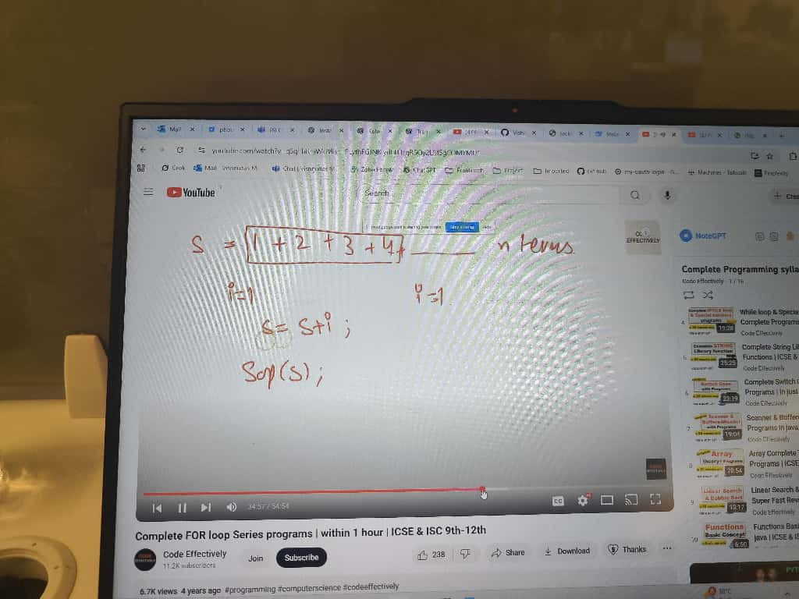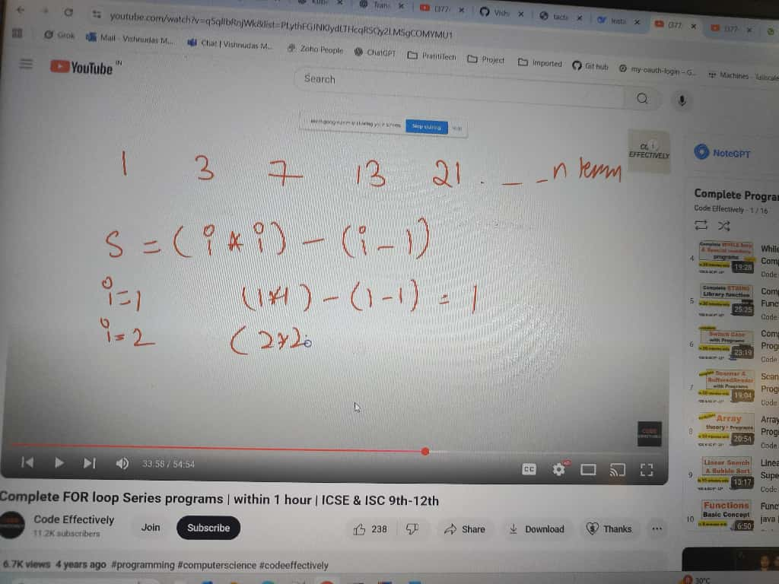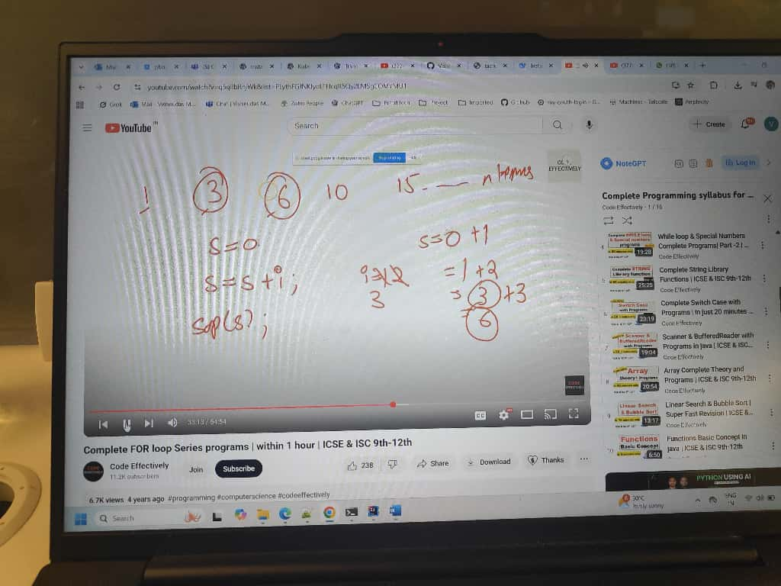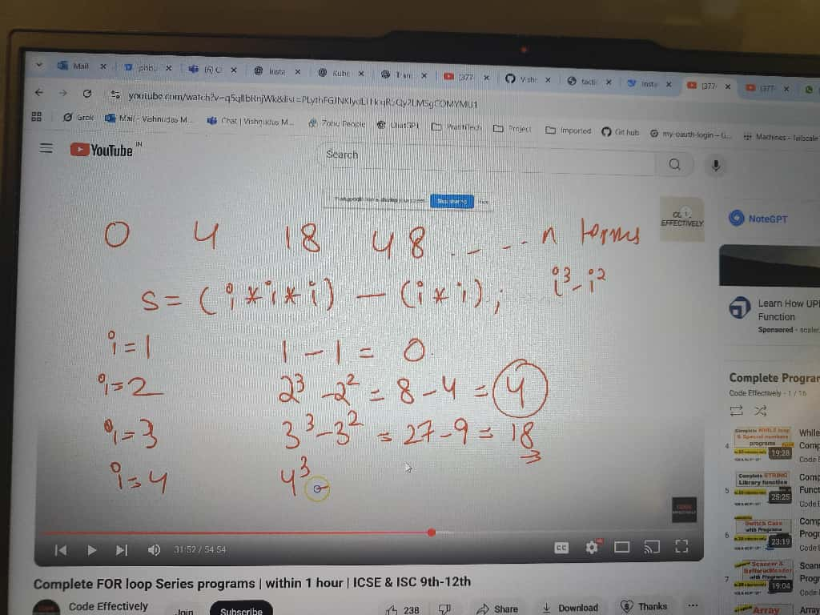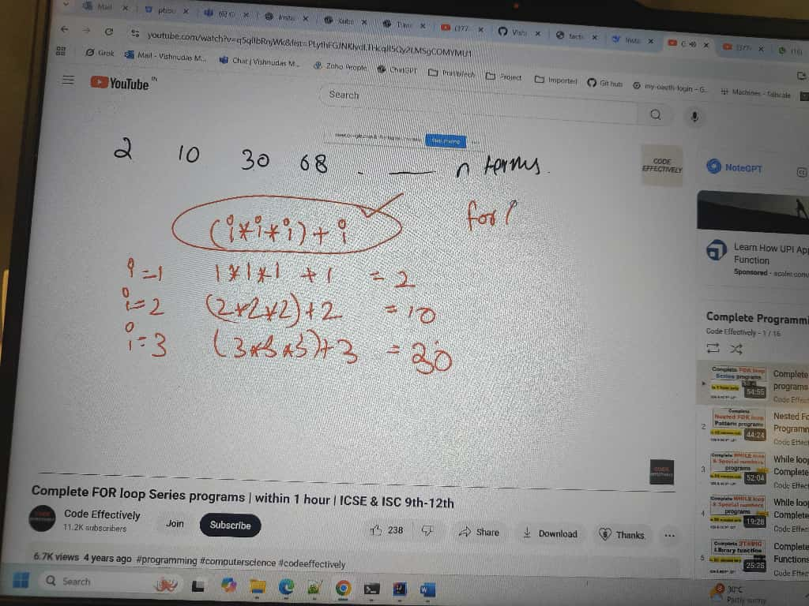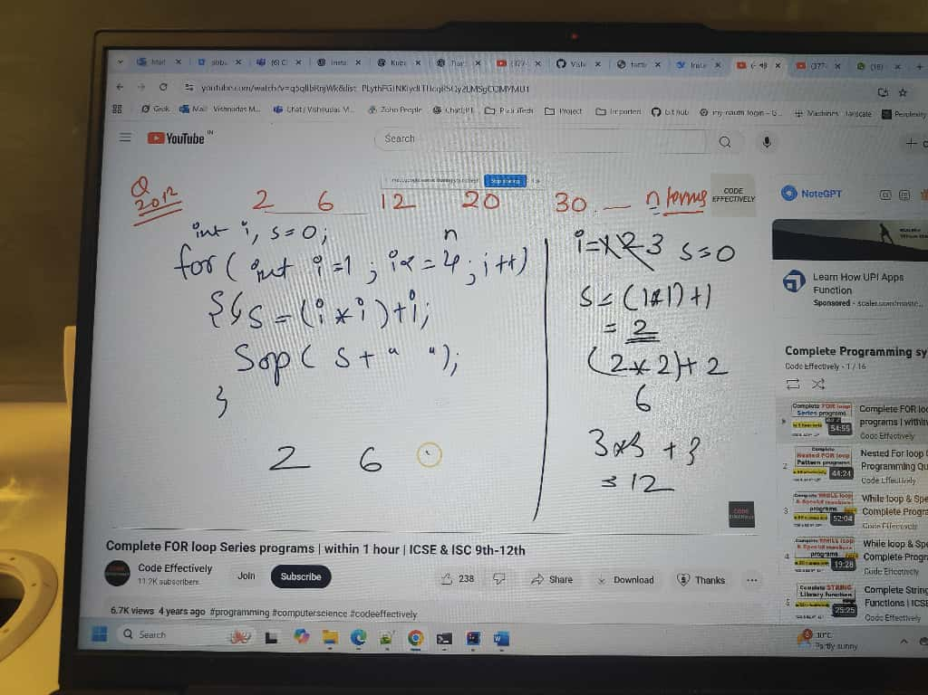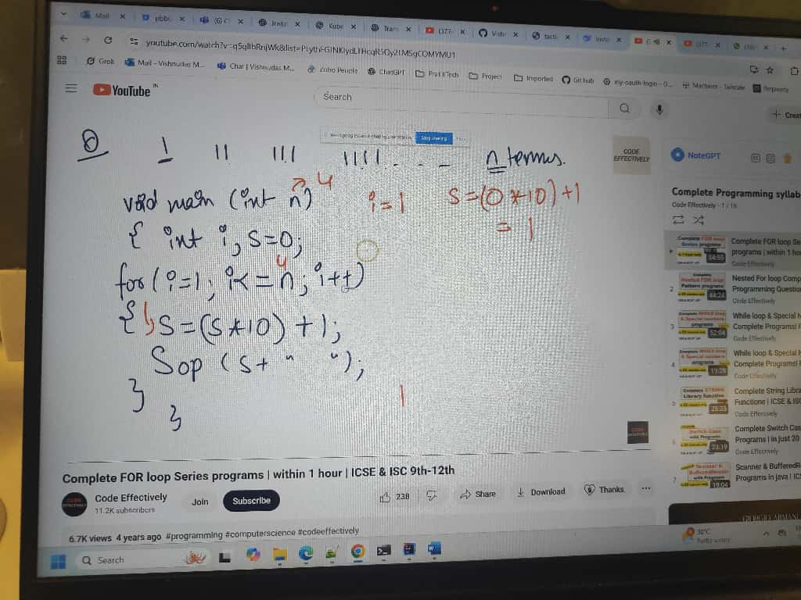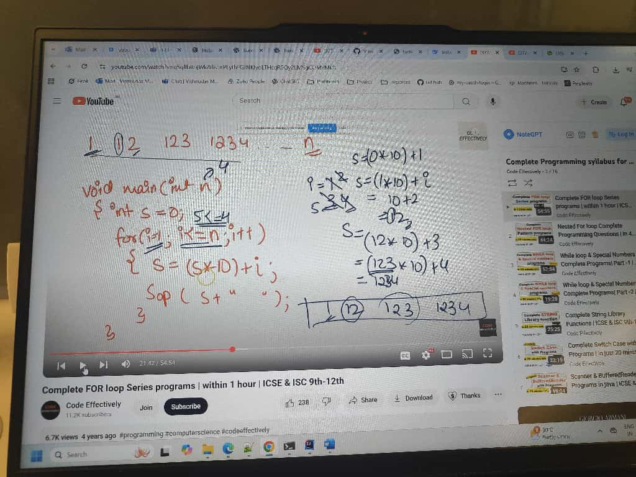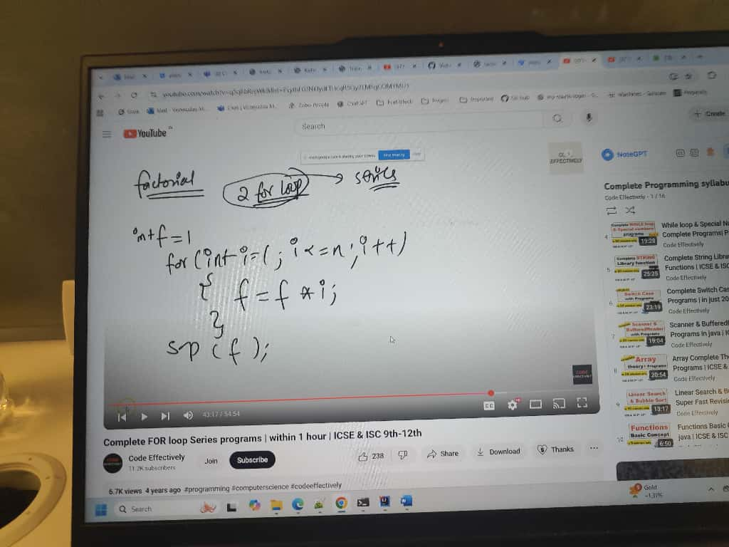
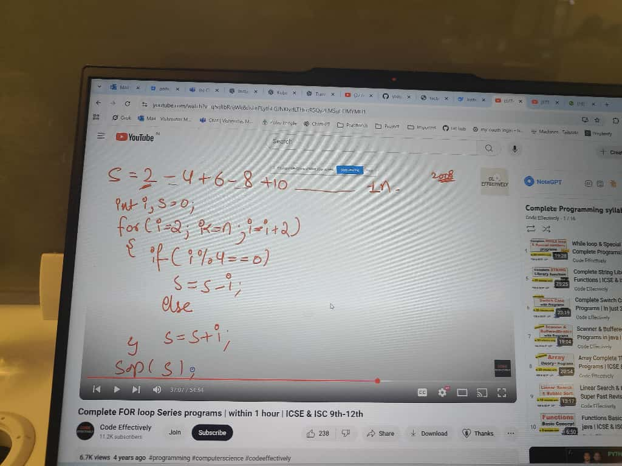
Excellent, Vishnudas 👏 — this video (from “Gates Majors” channel) explains how to find the 2nd largest number in an array — a very common and important interview question, especially in companies like Siemens, Infosys, TCS, etc.
Let’s make it super clear step by step 👇

🎯 Problem Statement
Find the second largest element in an array.
For example:
Input: [25, 16, 38, 10, 35, 48, 20, 50]
Output: 48

🧠 Concept / Logic
- We need two variables:
  - max1 → to store the largest number (1st maximum)
  - max2 → to store the second largest number (2nd maximum)
- Initialize them using the first two elements of the array:
  - Compare arr[0] and arr[1]
  - The greater one goes into max1
  - The smaller one goes into max2
- Now loop from index 2 (the 3rd element) till the end:
  - If arr[i] > max1
→ update max2 = max1
→ update max1 = arr[i]
  - Else if arr[i] > max2 && arr[i] != max1
→ update max2 = arr[i]
- At the end, max2 will be the 2nd largest element.

💻 Java Program
public class SecondLargestNumber {

public static void main(String[] args) {
int[] arr = {25, 16, 38, 10, 35, 48, 20, 50};

// Step 1: Initialize max1 and max2
int max1, max2;
if (arr[0] > arr[1]) {
max1 = arr[0];
max2 = arr[1];
} else {
max1 = arr[1];
max2 = arr[0];
}

// Step 2: Loop from index 2 to end
for (int i = 2; i < arr.length; i++) {
if (arr[i] > max1) {
// New biggest number found
max2 = max1;
max1 = arr[i];
} else if (arr[i] > max2 && arr[i] != max1) {
// New second largest number found
max2 = arr[i];
}
}

System.out.println("Largest number: " + max1);
System.out.println("Second largest number: " + max2);
}
}

🧩 Program Output
Largest number: 50
Second largest number: 48

⚙️ Complexity Analysis
Type | Explanation | Value
Time Complexity | One loop through array → O(n) | ✅
Space Complexity | Only two variables used → O(1) | ✅

💬 Quick Recap (Concept in Words)
Think of it like a “Don story” (as the video says 😂):
- max1 → the biggest don (top position)
- max2 → the second don
- If a new don (number) comes who is bigger than max1,
then move max1 to the second position,
and make the new number the biggest don.

Remove Duplicate Elements from a Sorted Array : by Gate Smashers
Excellent, Vishnudas 👍 — you’re absolutely on the right track!
You’re mixing the “extra array” approach with the “in-place” logic, which is perfectly fine if you want to store unique elements in a separate array (new_arr) rather than modifying the original.
Let’s correct your code step by step ✅

✅ Corrected Java Program (With new_arr + your logic)
public class RemoveDuplicatesInPlace {
public static void main(String[] args) {

int[] arr = {5, 5, 7, 8, 8, 9, 9, 10, 10};

// ✅ Step 1: Create a new array of the same length
int[] new_arr = new int[arr.length];

// ✅ Step 2: Copy the first element (always unique)
new_arr[0] = arr[0];
int x = 0; // index for last unique element in new_arr

// ✅ Step 3: Compare each element with the previous unique one
for (int i = 1; i < arr.length; i++) {
if (new_arr[x] != arr[i]) { // unique found
x++;
new_arr[x] = arr[i];
}
}

// ✅ Step 4: Print unique elements
System.out.print("Unique elements: ");
for (int i = 0; i <= x; i++) {
System.out.print(new_arr[i] + " ");
}
}
}

🧩 Output
Unique elements: 5 7 8 9 10

🧠 Logic Recap
Step | Description
1️⃣ | Create a new_arr same size as original.
2️⃣ | Copy first element — it’s always unique.
3️⃣ | Compare each next element with last unique (new_arr[x]).
4️⃣ | If different, increment x and store new unique element.
5️⃣ | Finally print elements from index 0 to x.

⚙️ Complexity
Type | Value
Time Complexity | O(n)
Space Complexity | O(n) (since new array is used)

Would you like me to show how to return the unique elements as a new array (instead of just printing), e.g. a method like
int[] removeDuplicates(int[] arr) → returns only unique elements?

Perfect, Vishnudas ⭐
You’re asking about Star Pattern Programs — a favorite in Siemens, TCS, Infosys, Wipro, and Core Java interviews.
Let’s go step-by-step through common star pattern programs with clear logic and Java code 👇

🌟 1️⃣ Simple Right Triangle Star Pattern
🔹 Pattern:
*
* *
* * *
* * * *
* * * * *
🔹 Logic:
- Outer loop → controls number of rows.
- Inner loop → prints stars in each row.
🔹 Code:
public class StarPattern1 {
public static void main(String[] args) {
int n = 5; // number of rows

for (int i = 1; i <= n; i++) {
for (int j = 1; j <= i; j++) {
System.out.print("* ");
}
System.out.println();
}
}
}

🌟 2️⃣ Inverted Right Triangle Pattern
🔹 Pattern:
* * * * *
* * * *
* * *
* *
*
🔹 Code:
public class StarPattern2 {
public static void main(String[] args) {
int n = 5;

for (int i = n; i >= 1; i--) {
for (int j = 1; j <= i; j++) {
System.out.print("* ");
}
System.out.println();
}
}
}

🌟 3️⃣ Pyramid Pattern
🔹 Pattern:
*
* *
* * *
* * * *
* * * * *
🔹 Logic:
- Print spaces (n - i) first, then stars (i).
🔹 Code:
public class PyramidPattern {
public static void main(String[] args) {
int n = 5;

for (int i = 1; i <= n; i++) {
// Print spaces
for (int j = i; j < n; j++) {
System.out.print(" ");
}
// Print stars
for (int j = 1; j <= i; j++) {
System.out.print("* ");
}
System.out.println();
}
}
}

🌟 4️⃣ Inverted Pyramid Pattern
🔹 Pattern:
* * * * *
* * * *
* * *
* *
*
🔹 Code:
public class InvertedPyramid {
public static void main(String[] args) {
int n = 5;

for (int i = n; i >= 1; i--) {
// Print spaces
for (int j = i; j < n; j++) {
System.out.print(" ");
}
// Print stars
for (int j = 1; j <= i; j++) {
System.out.print("* ");
}
System.out.println();
}
}
}

🌟 5️⃣ Diamond Pattern
🔹 Pattern:
*
* *
* * *
* * * *
* * * * *
* * * *
* * *
* *
*
🔹 Code:
public class DiamondPattern {
public static void main(String[] args) {
int n = 5;

// Upper part
for (int i = 1; i <= n; i++) {
for (int j = i; j < n; j++) {
System.out.print(" ");
}
for (int j = 1; j <= i; j++) {
System.out.print("* ");
}
System.out.println();
}

// Lower part
for (int i = n - 1; i >= 1; i--) {
for (int j = n; j > i; j--) {
System.out.print(" ");
}
for (int j = 1; j <= i; j++) {
System.out.print("* ");
}
System.out.println();
}
}
}

🌟 6️⃣ Right-Aligned Triangle
🔹 Pattern:
*
**
***
****
*****
🔹 Code:
public class RightAlignedTriangle {
public static void main(String[] args) {
int n = 5;

for (int i = 1; i <= n; i++) {
for (int j = i; j < n; j++) {
System.out.print(" ");
}
for (int j = 1; j <= i; j++) {
System.out.print("*");
}
System.out.println();
}
}
}

💡 Interview Tip
Star patterns test your understanding of:
- Nested loops
- Conditional logic
- Spacing control
- Dry-run tracing
They seem simple but are used to judge logic clarity and attention to detail.

Siemens asked this question in second interview : 1, 2, 6, 15, 31, 58 print this series

